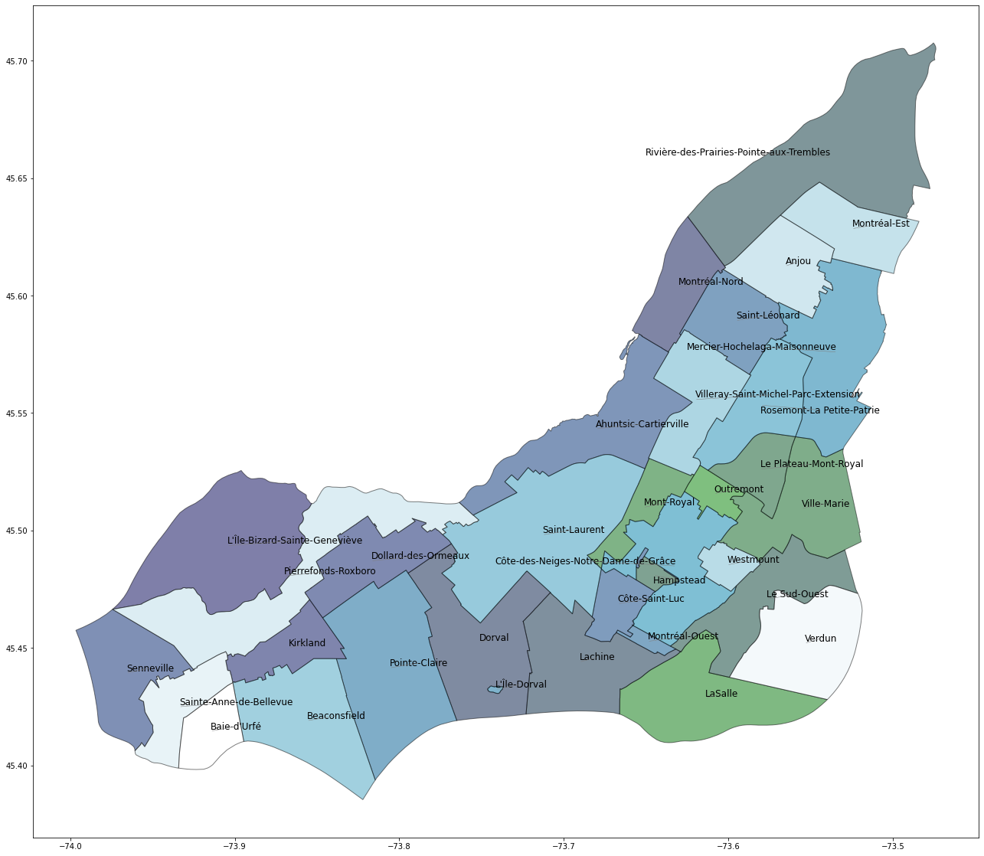

Greater Montreal Crime Data Analysis

DS8007 Final Project: Soheer Choudhry – April 2022

# Problem Definition

A key challenge for police departments across major metropolitan cities is how best to allocate resources in order to effectively address and combat crime. Key elements to determine are when and where police officers will patrol based on areas or times that see higher occurrences of crime as well as the severity of crime.

The key questions to be answered are as follows:

* What type of crime is more prevalent over others?
* What month(s) is criminal activity most likely to occur (including the types of crime)?
* What communities are more afflicted with criminal activity over others (including the types of crime)?
* How has criminal activity changed over the 6-year period in question?

This paper will address these questions through an analysis of open-source crime data for the greater Montreal area that covers the period from January 2015 to December 2020 (and where applicable, the first 8 months of 2021).

# Data Description

The crime data for the greater Montreal area was obtained from Kaggle.com, which is available at the following link:

<https://www.kaggle.com/stevieknox/montreal-crime-data>.

This dataset includes 10 columns and roughly 137,000 rows. The dataset provides the type of crime (6 possible categories), the neighbourhood where it occurred (along with latitude / longitude coordinates) as well as the date of occurrence.

In addition, data to support map visualizations and required boroughs data was obtained from the City of Montreal, found at the following link:

<https://donnees.montreal.ca/ville-de-montreal/polygones-arrondissements>

## Attributes

The Montreal crime data file, which is in csv format, included the following attributes:

* Category – This is the type of crime categorized into 6 possible values, as follows: Motor vehicle theft; Home invasion; Mischief; Theft in / from a motor vehicle; Confirmed theft; and Offenses resulting in death
* Date – The date of the incident in yyyy-mm-dd format
* Postal Code – The postal code of where the incident took place
* City – The city / suburb of where the crime took place and includes a list of 28 municipalities
* Neighbourhood – The neighbourhood / borough where the crime took and includes a list of 58 unique area; this is a subset of ‘City’ (i.e., list of options depends on selected ‘City’ field)
* Year – This is the yyyy only component of the Date field
* Count – This is the number of occurrences the crime took place; for each row the value is 1 given that each row represents only 1 incident; this column is included to support data aggregation when grouping across any of the other columns
* Longitude – the longitudinal value of where the incident took place
* Latitude – the latitudinal value of where the incident took place

The GeoJSON file is used to visualize the underlying map of the greater Montreal area and includes the Polygons delimiting each of the municipalities and neighbourhoods (or boroughs) that make up greater Montreal by providing the coordinates that defines the boundaries of each. In total, there are 28 municipalities and 51 boroughs.

## Analysis

The analysis is performed by first exploring the types of crime, the characteristics of each including trending over a 6-year time period. Subsequently, the location of crime is then analysed by city and subsequently by borough.

### Categorical Crime Data – Annual

The following charts illustrates crime categories over a 5-year time period. The first chart illustrates 5 categories, however a 6th category, ‘Offences Resulting in Death’, is plotted on a separate graph given the scale of data.

In analyzing Crime Occurrence by Category, it is clear the Home Invasion is the most prominent prime across all crime categories, however the occurrence of crime in this category has been steadily decreasing during the given time period. The next most prominent crime category is Theft in / from a motor vehicle, which also appears to be decreasing annually. The third most prominent crime category is Mischief. Like the top two crime types, Mischief appears to be decreasing annually, albeit at a slower pace. Comparing Mischief against Home Invasion clearly shows that the rate of decrease of Home Invasion has been decreasing at a faster much pace when compared to Mischief, having narrowed the occurrence gap materially between the two during the time period in question. Motor vehicle theft and Confirmed Theft appears to have remained relatively constant with observable fluctuations from year-to-year.

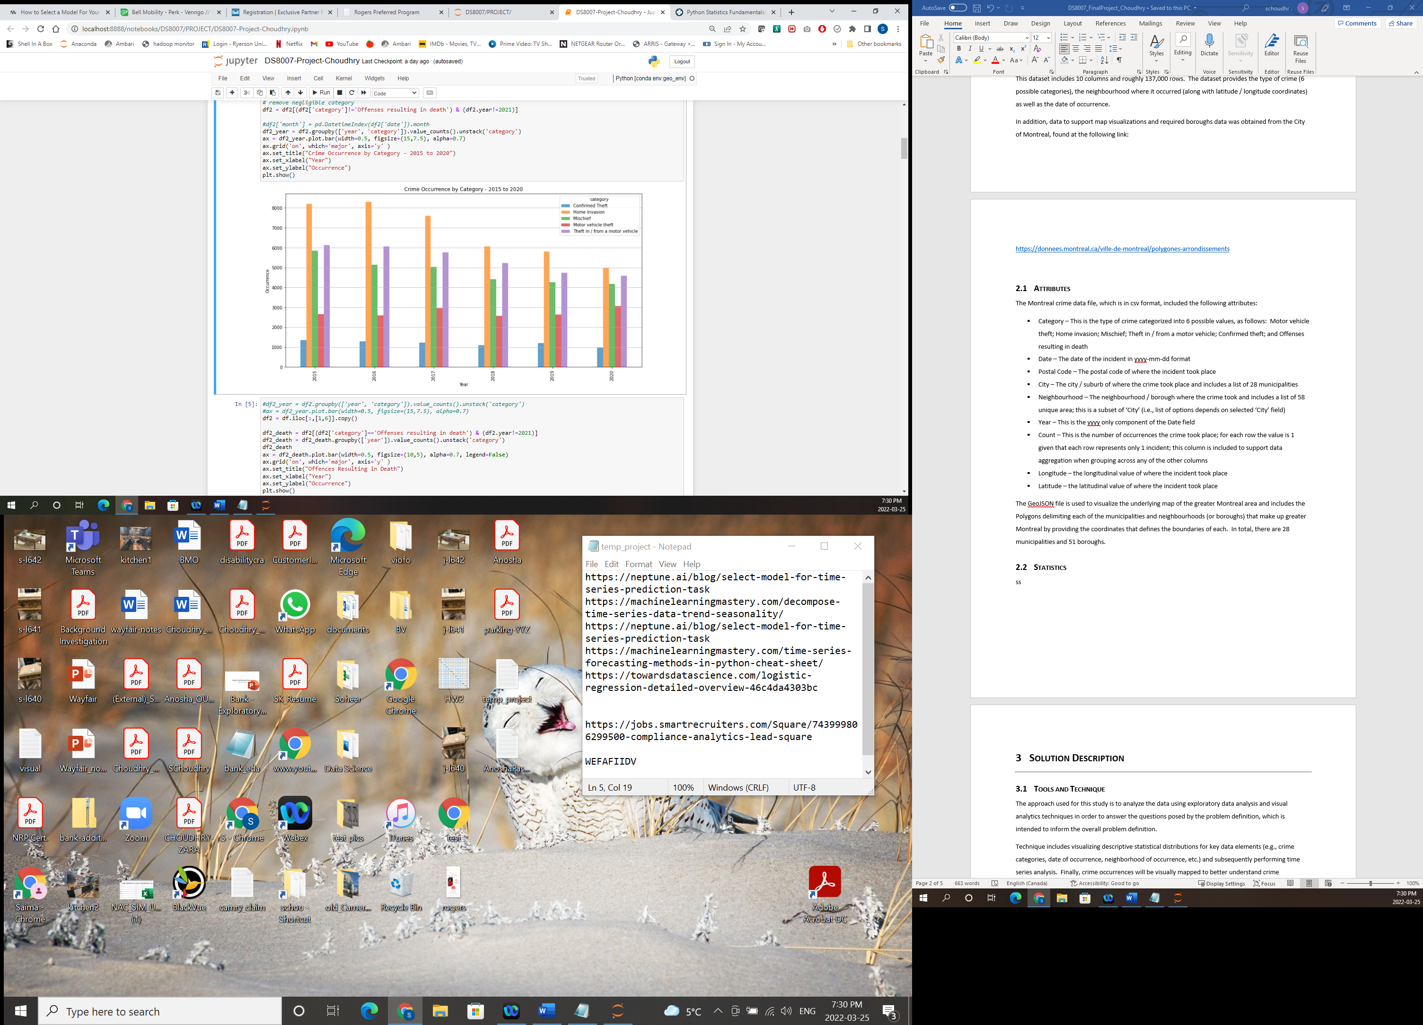

Offences resulting in death has remained relatively constant at roughly 20 occurrences annually for the greater Montreal area. Although, the number of occurrences of this crime had been trending lower between 2015 to 2017 but trended back upward.

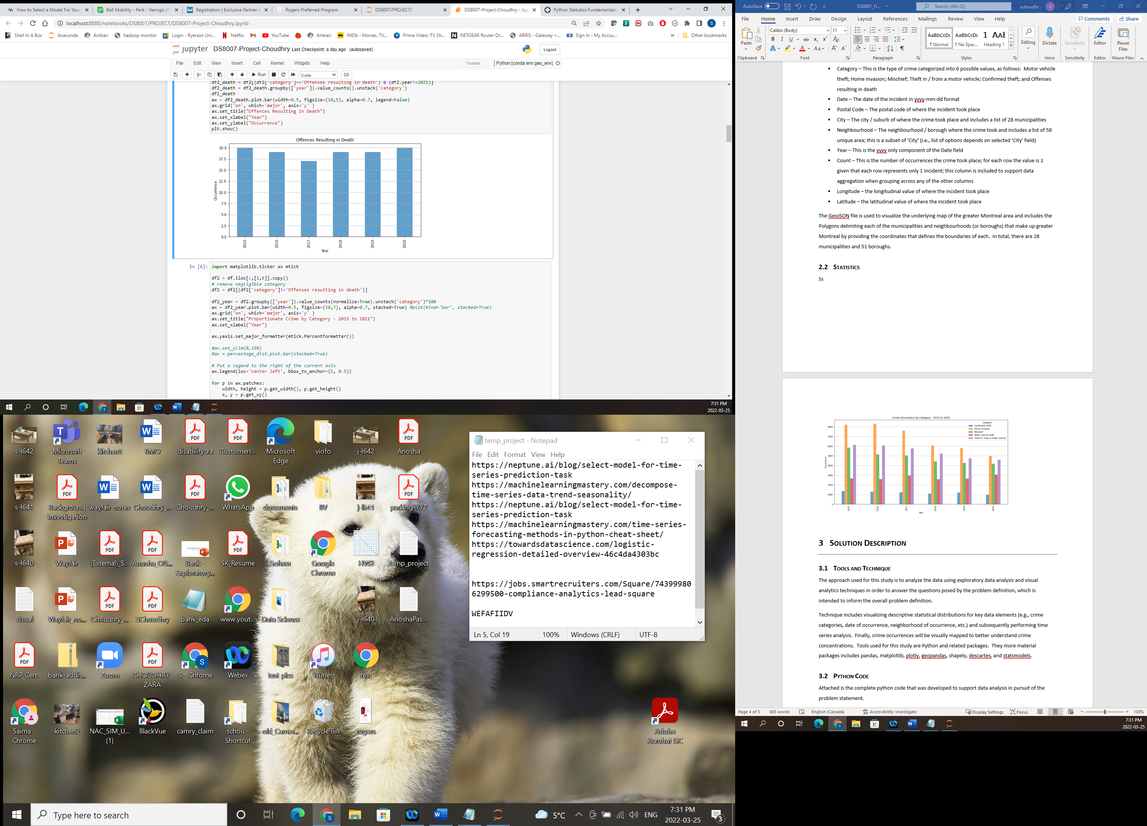

The following graph further supports that, in aggregate for the greater Montreal area, it appears all crime categories have been declining, except for Motor vehicle theft. Home invasions have been declining annually, in some years at quite a high rate (from 2015 to 2020 a roughly 40% drop in occurrences). Confirmed theft and mischief have declined in total, both by about 29% during this time period. Motor vehicle theft, however, has increased 15% from 2015 to 2020.

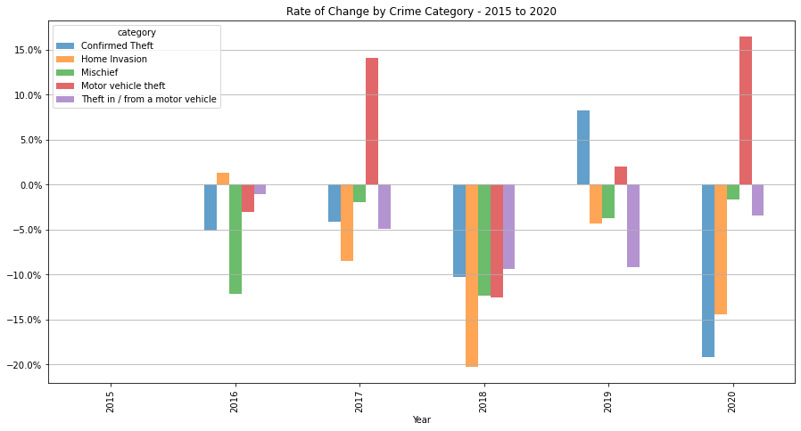

Proportionally, the top three crime categories comprise most of the share of crime for each year however collectively the top three categories have been trending lower. That is, in 2015 and 2016 the annual share of crime for the top three categories was around 83% but from there the share of crime had consistently trended lower where in 2020 the value fell to about 77%. Conversely, the share of Motor vehicle crime had consistently increased over the same time period where in 2015 it was roughly 11% and by 2020 increased to roughly 17%.



### Categorical Crime Data – Monthly

This section analysis categorical crime data by month and aims to uncover trending insights, including potential seasonality patterns.

The following graphs illustrates monthly trending for all crime types combined in aggregate, followed by each crime type. For each, a graph illustrates the number of occurrences for each month, followed by the month-over-month change over time period in question. Note that 2021 data is only available up until the month of August, inclusive.

For all crime types in aggregate, but for 2020/2021 the general trend appears to be similar whereby there is a general decrease in the first month or two, which then begins to pick up and somewhat level off become beginning to decline again in the last couple of months. In 2020 and 2021, there appears to be a material decrease and a downward dip in crime for the first couple of months, but then tends to increase and like the other years, 2020 can be seen experiencing a decrease in crime occurrences near the end of the year. The month-over-month change more clearly supports this observation where it can be clearly seen that crime in aggregate from November to February (inclusive) experiences a decrease in crime, which then begins increasing again for the remainder of months (but for a few exceptions).

Observations for each crime category are as follows:

* Motor vehicle theft – No clear observable trend from the graphs below, but for 2021 where there appears to be a material increase in Motor vehicle theft between the months of March to July, inclusive, followed by a material decrease in August.
* Home invasion – But for the annual decrease in the number of occurrences, the monthly trend across all years appears roughly similar. The month-over-month graph shows that between November to February, inclusive, occurrences of this crime type tend to decrease and then generally increase for the remaining months. This may be explained possibly by the fact that families tend to be away from home more often in months when the weather is more temperate, and schools are closed versus during cold winter months.
* Mischief – Like Home invasion, occurrences of Mischief appear to be more prevalent between the November to February (inclusive) months against any other month during the year.
* Theft in / from a motor vehicle – There is no observable monthly trend for this crime category. While it appears that the general trend appears to increase each month, there are some months where the trend tends to decrease, albeit not consistently for all years. For example, this type of crime generally tends to decrease from November to January and then begin increasing again. Note that material decline in this crime type in 2020 beginning Marc to the month of May, which may be attributed to when COVID-19 lockdowns began taking effect.
* Confirmed theft – Similarly, there is no clear trend observable in these graphs for this crime type. Occurrences appear to decrease roughly between April to June and then begin trending upwards to the end of the year. The month-over-month change appears similarly mixed and almost random.
* Monthly Occurrences of Offences resulting in death – There appears to be no trend observable in these graphs, especially considering the relatively low number of occurrences experienced in this crime category

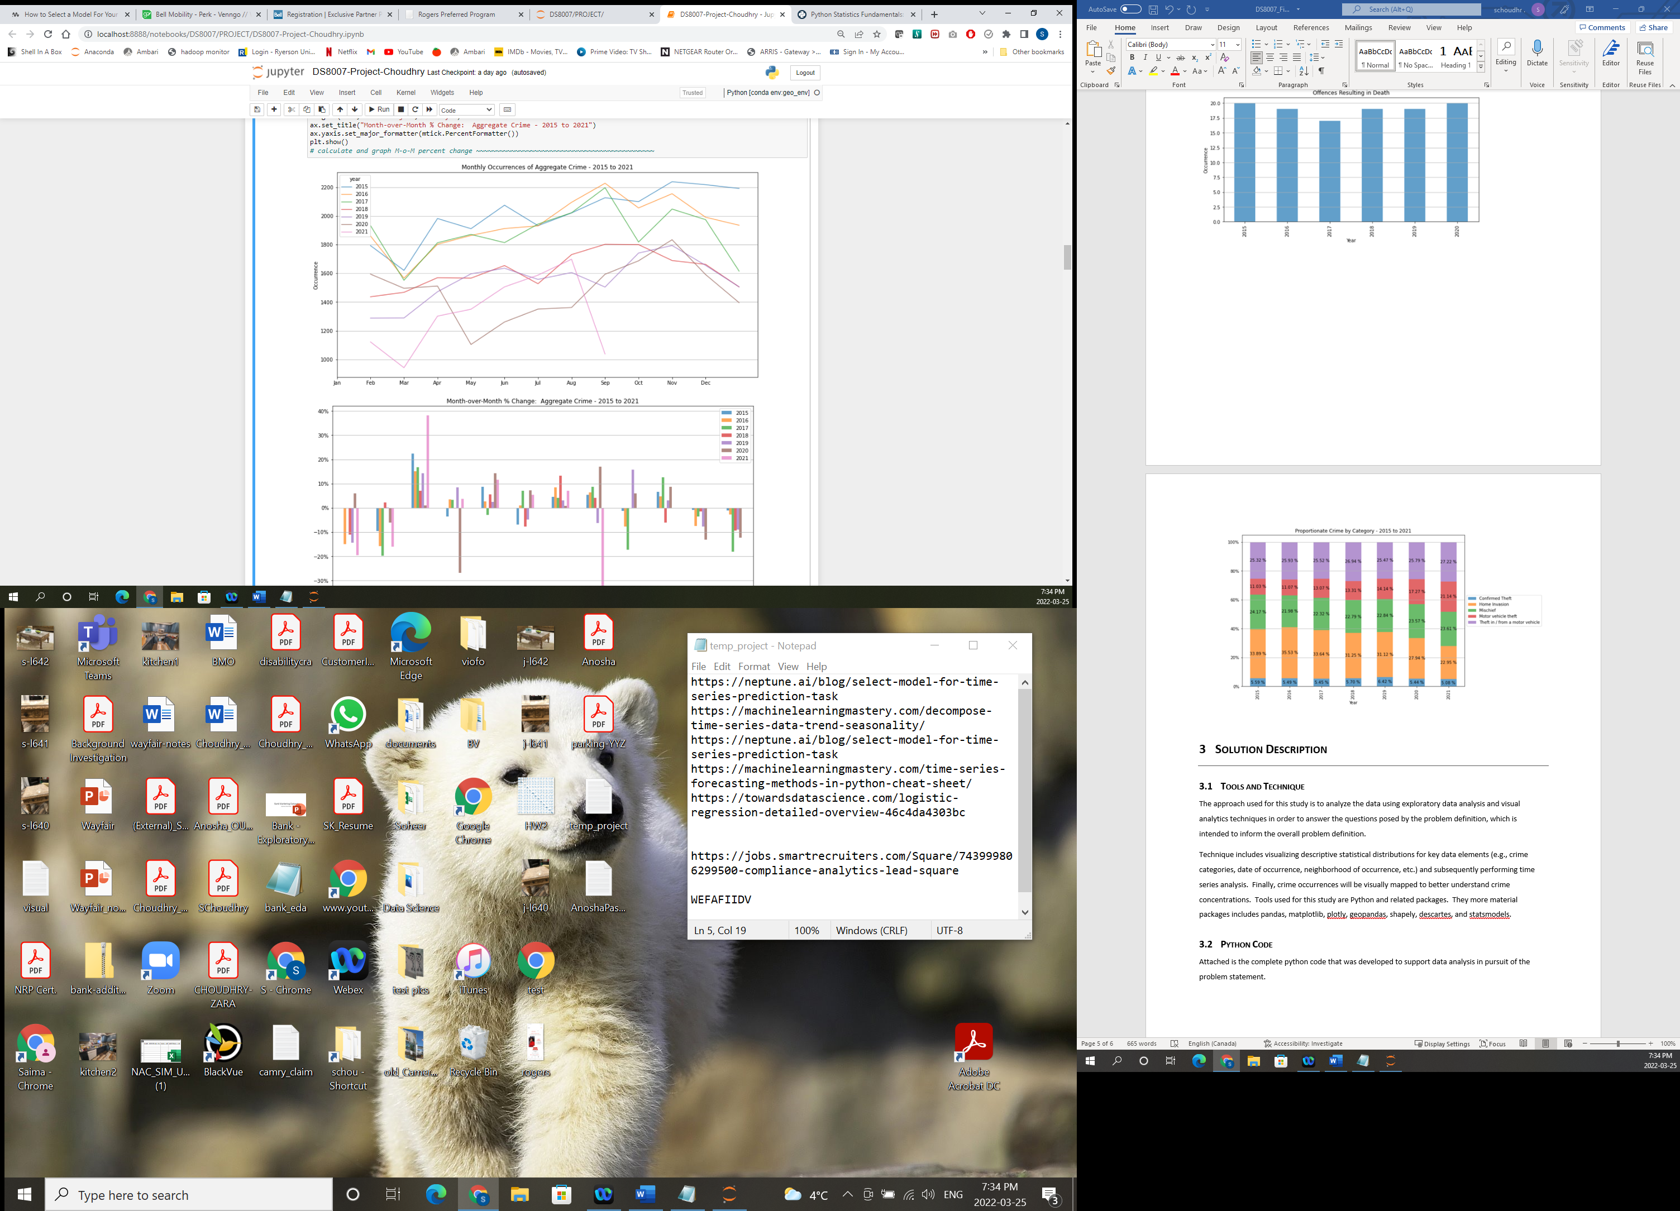

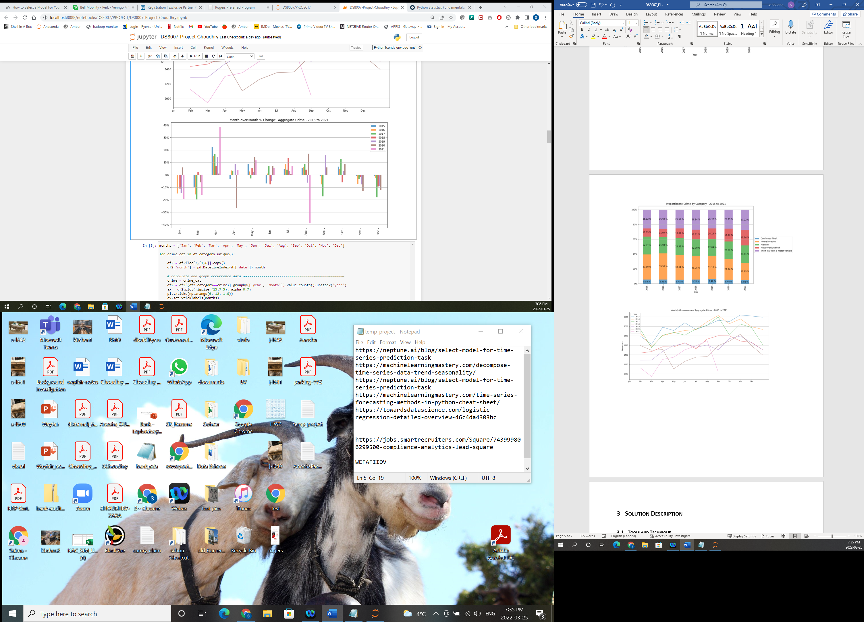







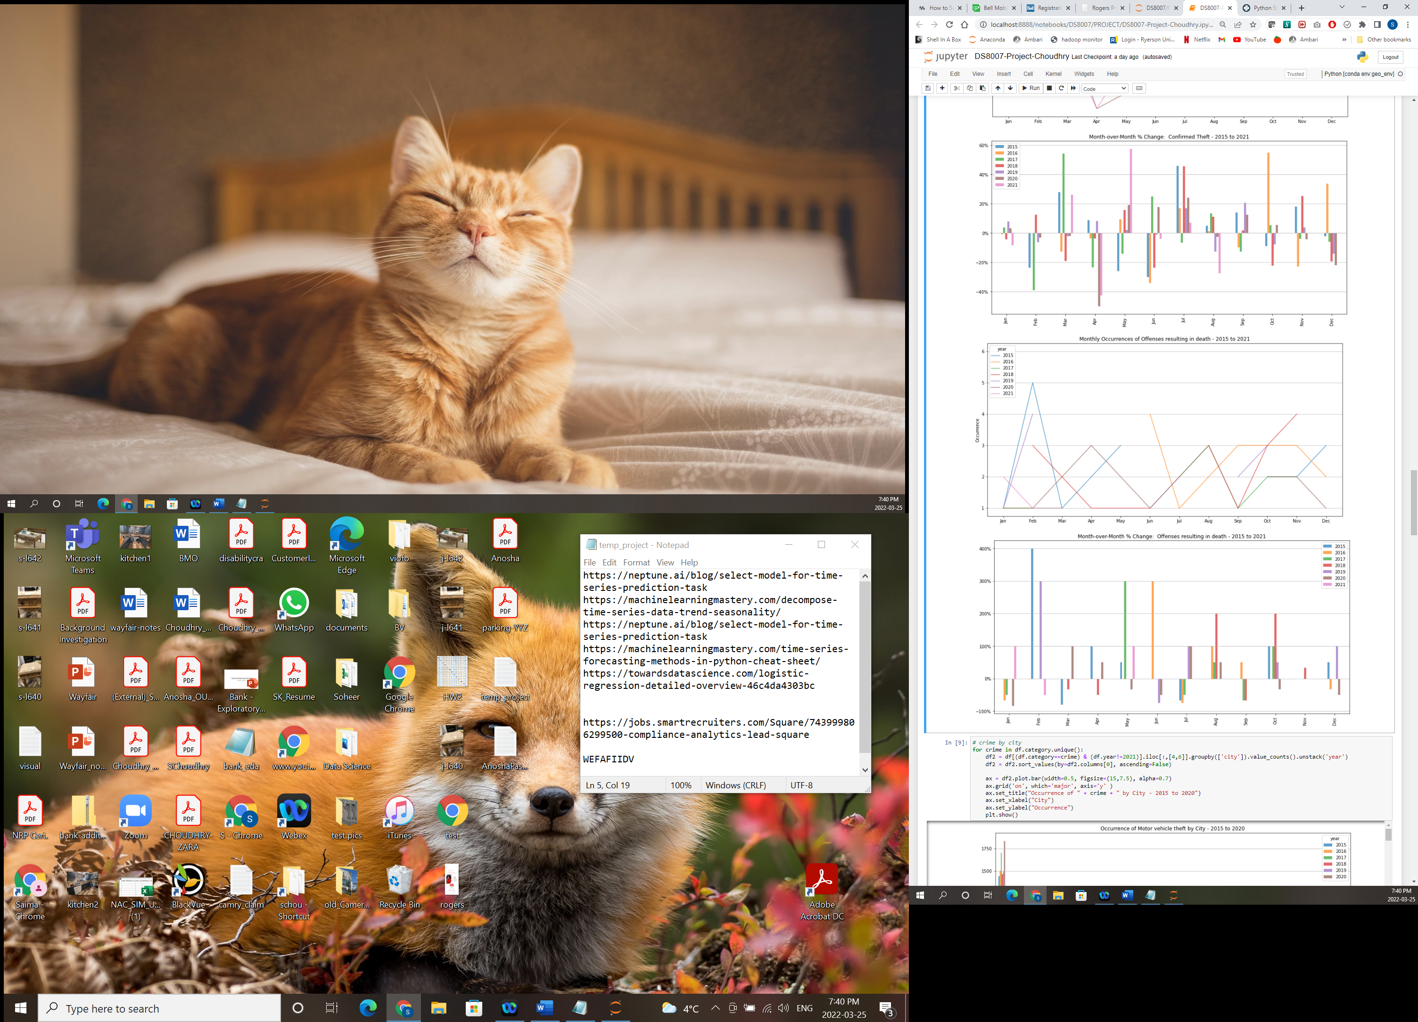

To further validate these observations, an end-to-end monthly time series (composed of 80 observations) for each crime category was decomposed to better uncover trends or seasonality characteristics that may produce additional or support prior insights. First, a Dickey-Fuller test was run in order to test for stationarity (i.e., whether any trends may exist) by assuming that if the p-value is less than 5% then we can assume non-stationarity (i.e., no trend), otherwise we may assume that there is a level of trending within the data. Refer to Appendix 7.1 for detailed output of the Dickey-Fuller test. Per the output, all crime categories assume some level of trend exists, except for the Offences resulting in death, which clearly suggests no underlying trend.

Each crime category time series was further analysed through decomposition by graphing each of the components in turn, namely, the original observed data; the underlying trend component; seasonality component; and the residual data component.

Key observations for each of the crime categories from below graphs are as follows:

* Motor vehicle theft – The trend component shows that this type of crime had been steadily increasing up until late 2017 but then reversed course and started declining but subsequently reversed course and is now on a steeper uptrend; an explanation for this may be due to increasing demand for vehicles and resulting vehicle prices once COVID-19 set in; the data also suggest a possible seasonality factor where this crime type occurs more often occurs in the middle of the year during the later summer / early fall months vs. any other month during the year
* Home invasion - We can see that the trend has been gradually decreasing over this time period, as was evident in previous observations, and like the Motor vehicle theft crime category also has a seasonality component suggesting that this crime type steadily increasing during the up until the fall months where it peaks and subsequently begins to drop again
* Mischief - This crime type also shows a decreasing trend over the given time period and with a seasonality factor that suggests that this begins to dramatically increase at the beginning of the year, peaking in the middle of the year during the summer months and then subsequently falling off near year-end before repeating this cycle again
* Theft in / from a motor vehicle - This crime type has been steadily decreasing since 2015 however, this trend appears to have reversed from late 2020 and is at the beginning of an upward trend; the data also suggests a seasonality component which suggests that this crime type is more prevalent in the late fall / early winter months
* Confirmed Theft - This crime type had been on a downward trend up until 2018 where it levels off and begins another gradual uptrend, which has since reversed course after peaking in late 2019; the seasonality component suggests that this crime type is more prevalent in the fall and early winter months, where it generally tends to peak before dropping off and resuming the cycle again











Per the below chart and graph, the rate of change for each crime category for Montreal specifically is like the aggregate view from a trending perspective, however the overall pace of change is slightly worse off across most crime categories.

For example, between 2015 to 2020 the decrease in home invasions is 40% in aggregate, but 37% for Montreal; confirmed theft and mischief decreased by about 28%, but mischief dropped only 25% for Montreal (no change for confirmed theft). Confirmed theft decreased by 29% in aggregate but only 27% for Montreal. Motor vehicle theft for Montreal increased by 27% as compared to only 15% in aggregate, which marks quite a large difference.

|  |  |  |
| --- | --- | --- |
| **Crime Category** | **Aggregate** | **Montreal only** |
| Confirmed Theft | -28.6% | -26.8% |
| Home Invasion | -39.5% | -36.7% |
| Mischief | -28.4% | -24.5% |
| Motor vehicle theft | 14.9% | 27.0% |
| Offenses resulting in death | 0% | 7.1% |
| Theft in / from a motor vehicle | -25.3% | -26.8% |

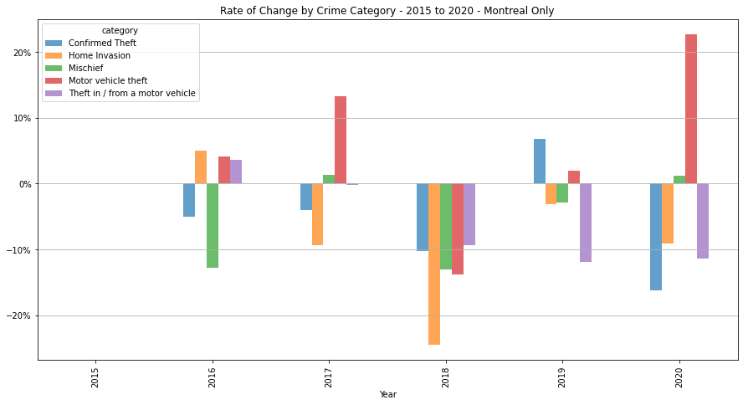

### Location Crime Data – City

The focus of this section is where the crime took place in order to better understood what cities or boroughs require more attention over others due to both the number of occurrences of crime and the type of crimes that are prevalent.

The following graphs illustrates crime occurrences by city to better understand what share of crime each city is afflicted by followed by further breaking down a given city by boroughs to determine key areas where crime may be concentrated in. As per below graphs, Montreal is consistently where the material share of crime occurs across any crime category and for any given year. The share of crime for Montreal for each of the crime categories, are as follows:

* Motor vehicle theft – Ranges between 56% to 59% with the next highest city being Montreal-Nord at around 7% to 10% with Saint-Laurent taking that spot in 2019 only at about 7%
* Home invasion – Ranges between 69% to 74% with the next highest city being Montreal- Nord at around 4% to 5%
* Mischief – Ranges between 66% to 70% with the next highest city being Montreal-Nord at around 4% to 6%
* Theft in / from a motor vehicle – Ranges between 65% to 71% with the next highest being Saint-Leonard at around 4% to 5%, however beginning 2018 Montreal-Nord took that spot onwards with a similar range between 4% to 5%
* Confirmed Theft – Ranges between 74% to 75% with the next highest city being Montreal-Nord at around 5% to 6%
* Offences resulting in death – Given the low volume of data for this category the range is broad being roughly between 60% to 80%, depending on the number of occurrences for a given year.

A key point to note is that this data has not been normalized based on population density given that a per capita measure of crime would provide more appropriate statistics and further inform this analysis.

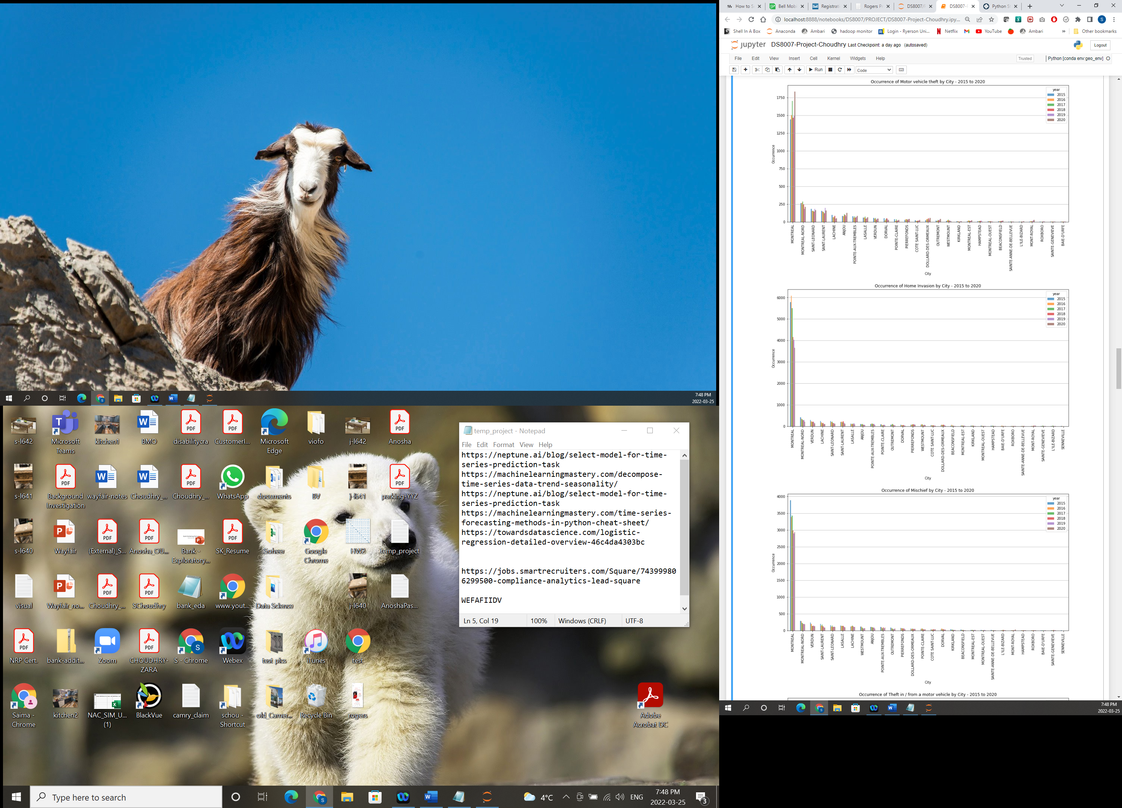

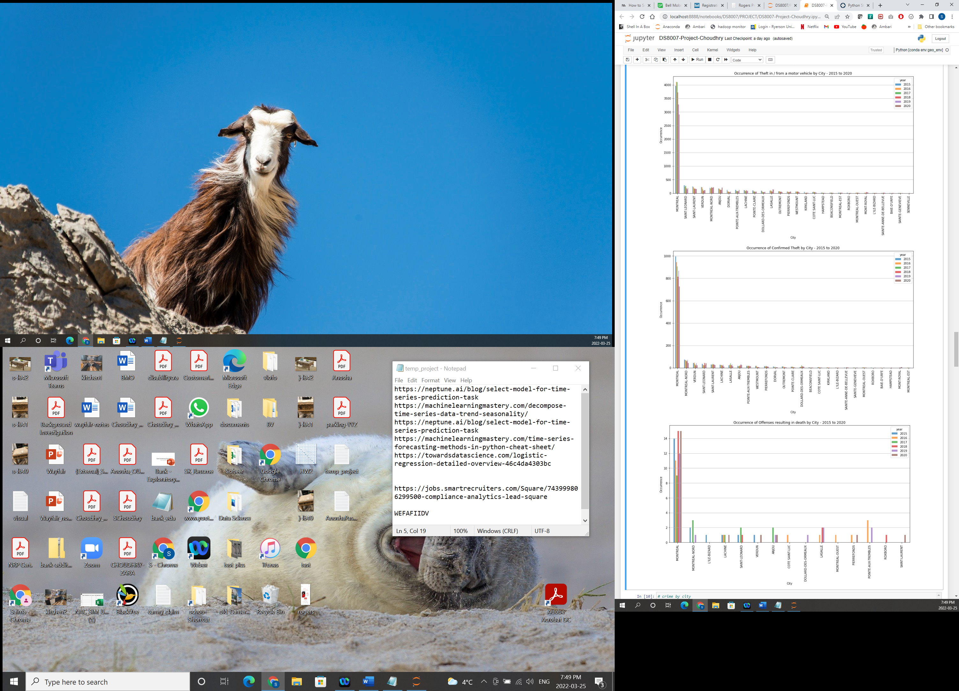

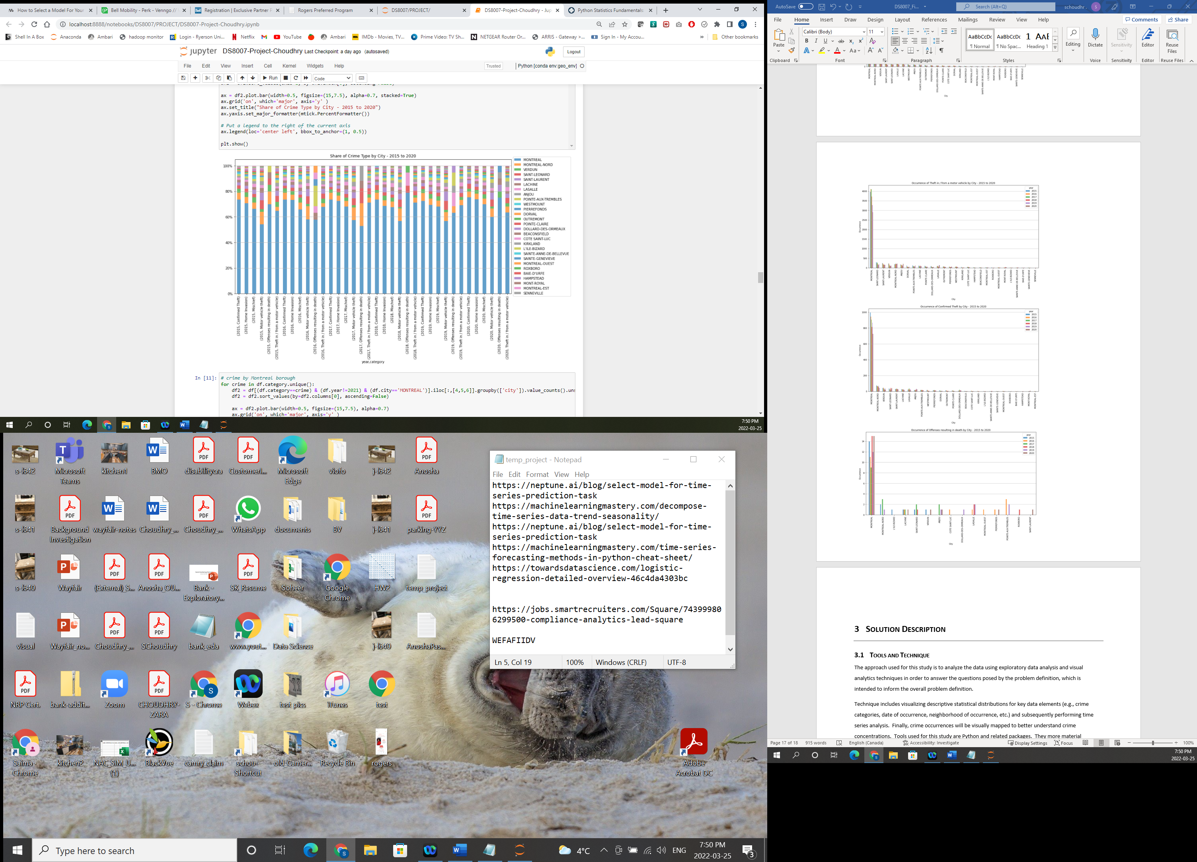

Given that Montreal accounts for most crime occurrences across all crime categories for any given year, the city is further analyzed by borough. Note that there are a total of 34 boroughs/neighborhoods that comprise the city of Montreal.

Refer to Appendix 7.2 for a visual map of crime occurrences by year and category. Below is a map of the municipalities and neighbourhoods of the greater Montreal area for visualization purposes. Note that Ville-Marie on the map is effectively Downtown Montreal.

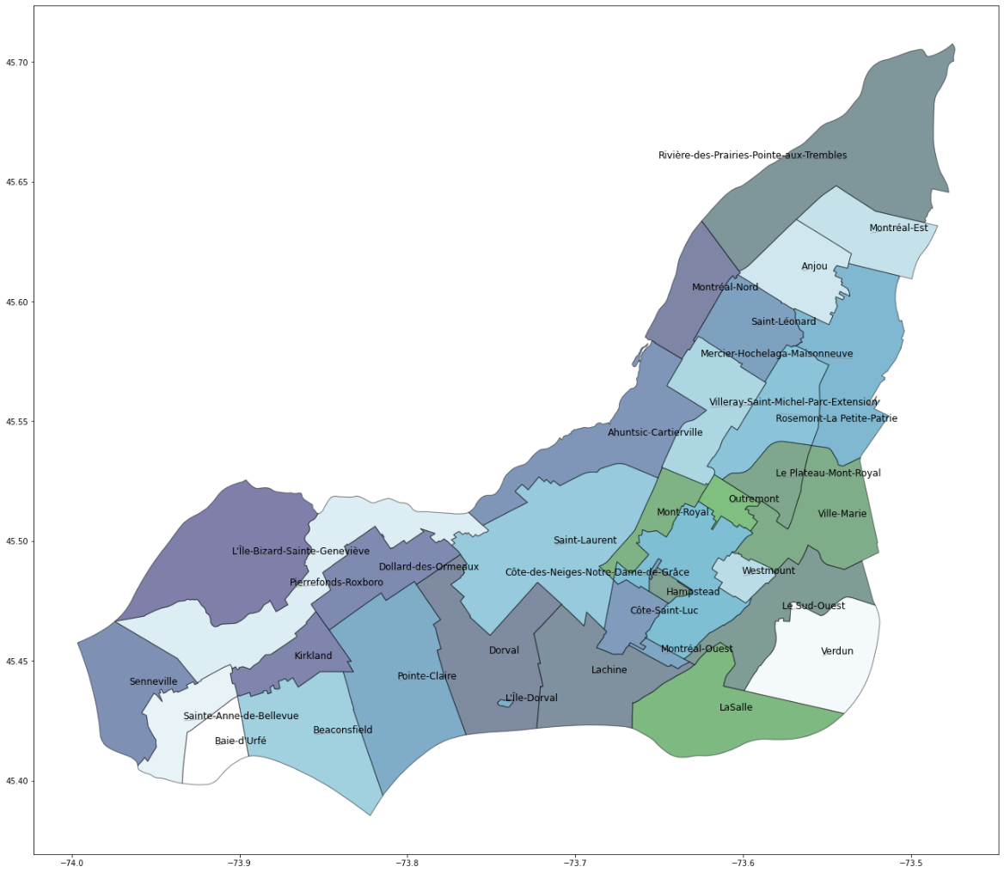

* Motor vehicle theft – Key neighborhoods that contribute to roughly a third of all occurrences is consistently Mercier and Ahuntsic (roughly around 10% for each of these areas) and depending on given year can be either Rosemount or Riviere-des-Prairies
* Home invasion – Key neighborhoods that contribute the most occurrences of this crime type is consistently Plateau Mont-Royal (roughly between 13% to 16%) and the Centre-Sud (roughly between 7% to 10%) and depending on given year can be either Rosemont, Mercier, Petite-Patrie or Downtown Montreal (roughly around 7% for any of these areas)
* Mischief – Key neighborhoods that contribute most to the share of all occurrences is consistently Plateau Mont-Royal (roughly between 12% to 14%), Centre-Sud (roughly between 8% to 10%) and Downtown Montreal (roughly between 6% and 10%). The only exception was in 2015 where Petite-Patrie contributed the third highest share of all occurrences at 6.4% as compared to Downtown Montreal (at fifth place), which contributed 6.3%.
* Theft in / from a motor vehicle – Key neighborhoods where occurrences of this crime are high are Downtown Montreal (between 10% and 17%), Plateau Mont-Royal (between 9% and 12%) and Centre-Sud (between 6% and 9%); however, Centre-Sud was replaced by Old Montreal in 2018 in the top three spot at 8% and in 2020 was replaced by Mercier at 8%
* Confirmed Theft – Key neighborhoods that consistently appear in the top three cities contributing the highest share of occurrences in this category are Plateau Mont-Royal and Downtown Montreal (both between 10% and 12%) and Centre-Sud (between 9% and 14%)
* Offences resulting in death – While the number of observations is small, key neighborhoods that consistently appear with more than one occurrence in at least two of the 6 years includes: Hochelaga, Plateau Mont-Royal and Downtown Montreal; overall, Montreal consistently accounts for most of this crime type, as per the chart below

|  |  |
| --- | --- |
| Proportion of Offences resulting in death - Montreal | |
| 2015 | 70.0% |
| 2016 | 57.9% |
| 2017 | 52.9% |
| 2018 | 78.9% |
| 2019 | 63.2% |
| 2020 | 75.0% |

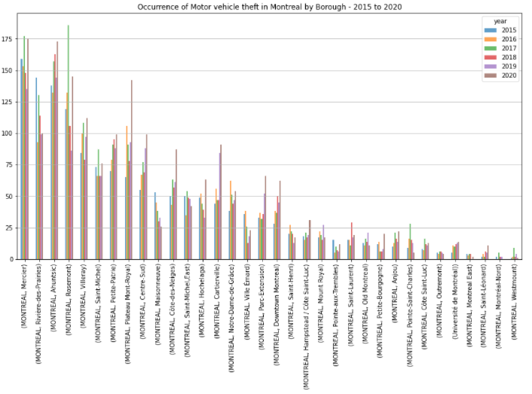

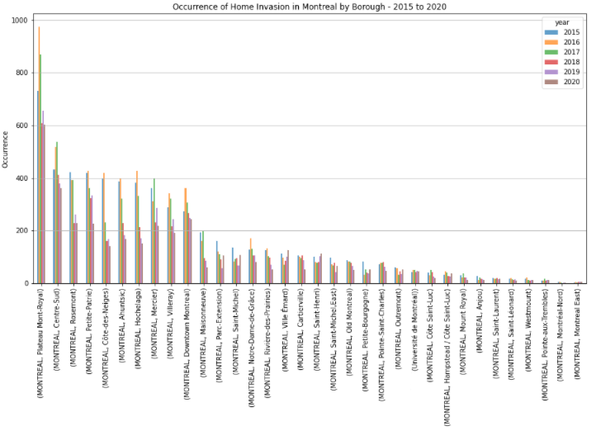

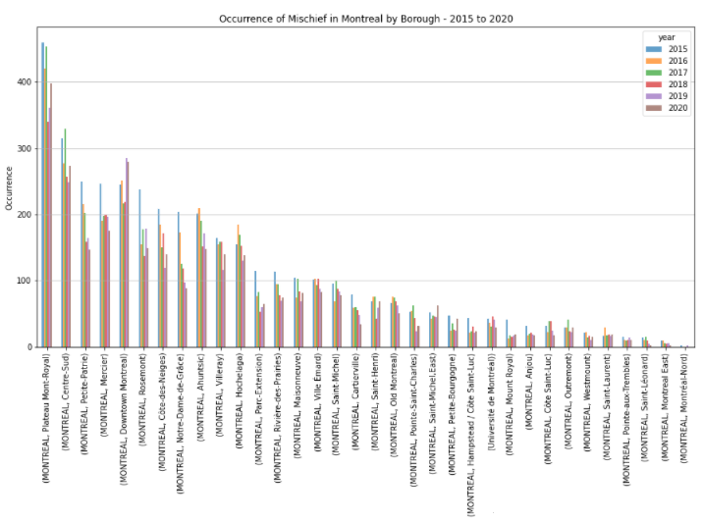

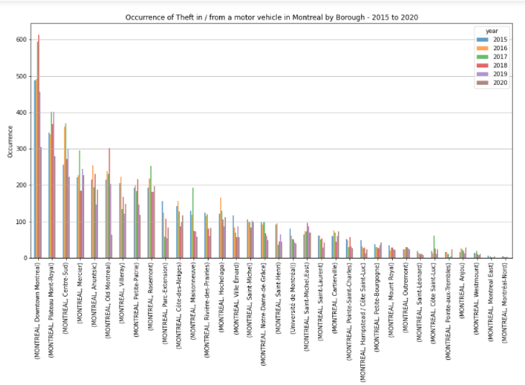

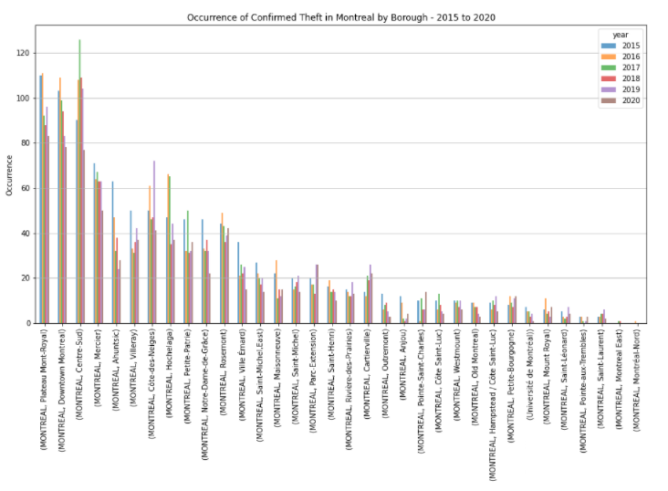

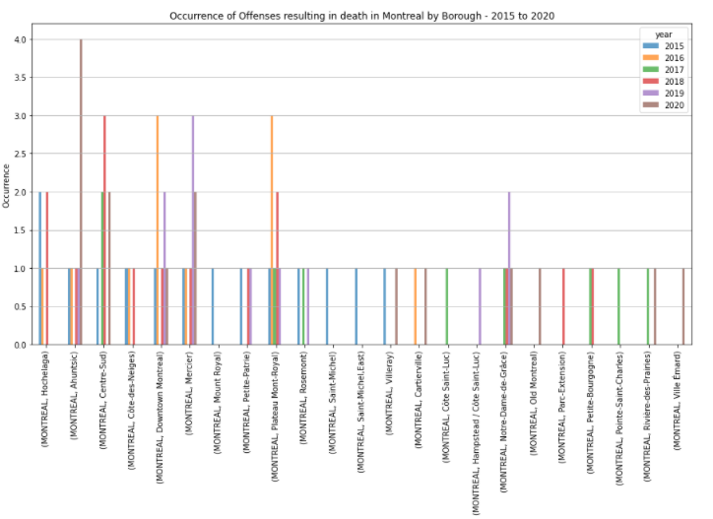

In reviewing the map visualizations in Appendix 6.2, it is evident that for any given crime category (except for offenses resulting in death), the density profile of crime occurrences for any given year is relatively similar across the region. This indicates that the pattern of crime occurrence appears to be consistent across crime types and geo-locations.

### Crime Occurrence Forecast – By Category

A 12-month forecast was completed in order to determine the possible trend going into the following year. Several models were evaluated, which included ARIMA, SARIMAX, Simple Exponential Smoothing and Exponential Smoothing. The approach was to split the data into test (two-thirds) and train (one-third) datasets. The train data set was used to fit the model and subsequently predict subsequent values up to the same number of observations as the test set. The predicted outputs and the test datasets were then used to compute the root mean square error (RMSE). This approach was used across all methods and based on the RMSE the ARIMA method appeared to be the best suited. Note that the pdq parameters were estimated through experimentation by running the model several times each time updating one or more parameters until the observed RMSE did not improve. Refer to Appendix 7.3 for the predicted output and test plots as well as the RMSE values.

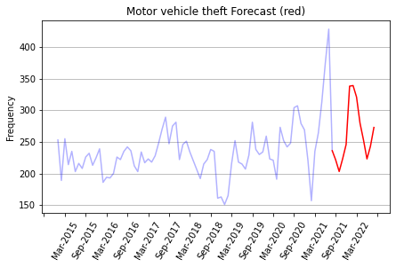

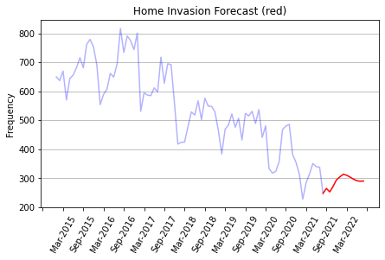

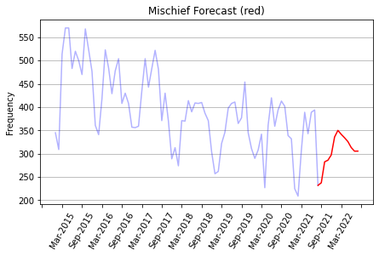

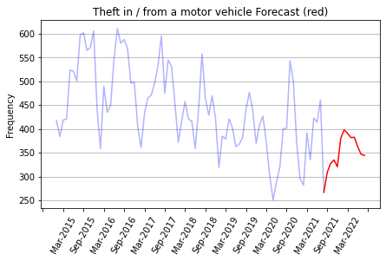

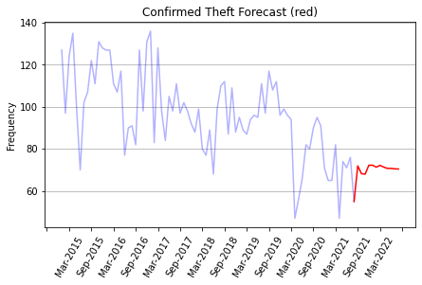

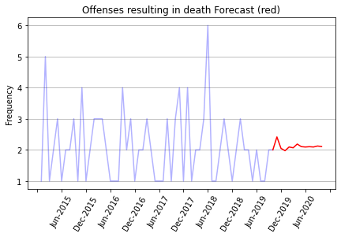

# Solution Description

## Tools and Technique

The approach used for this study is to analyze the data using exploratory data analysis and visual analytics techniques in order to answer the questions posed by the problem definition, which is intended to inform the overall problem definition.

Technique includes visualizing descriptive statistical distributions for key data elements (e.g., crime categories, date of occurrence, neighborhood of occurrence, etc.) and subsequently performing time series analysis. Finally, crime occurrences will be visually mapped to better understand crime concentrations. Tools used for this study are Python and related packages. They more material packages includes pandas, matplotlib, plotly, geopandas, shapely, descartes, and statsmodels.

# Data Insights

Key insights supporting the questions posed in the problem statement from our exploratory data analysis are as follows:

**What type of crime is more prevalent over others and how has criminal activity changed over the six-year period?**

The top three crime categories for the greater Montreal area are as follows:

* Home invasion – The most prominent category of crime comprising roughly 30% of total share annually, however the occurrence of this crime type has been rapidly declining. Between 2015 to 2020 (inclusive) home invasions dropped by 40%.
* Theft in / from a motor vehicle – The second highest category comprising roughly 25% of total share. In the same period this category of crime dropped by 29%.
* Mischief – Finally, this crime category, like the top two, has also experienced a declining trend, dropping 28% over the same time period. This crime type typically comprises roughly 23% of the total share of crime.

An interesting note is that the Motor vehicle theft is the only category of crime steadily increasing by 15% in this time period. Initially in 2015 Motor vehicle theft comprised only 11% of the total share of crime and by 2020 made up 17% of the total share.

The trend component from our decomposition analysis is as follows:

* Home invasion – consistent, declining trend

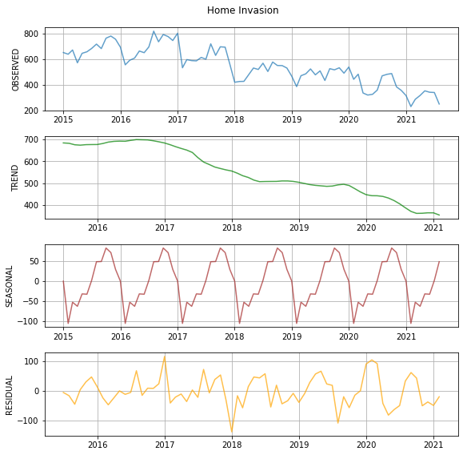

* Theft in / from a motor vehicle – initially a declining trend, which has subsequently reversed to an uptrend

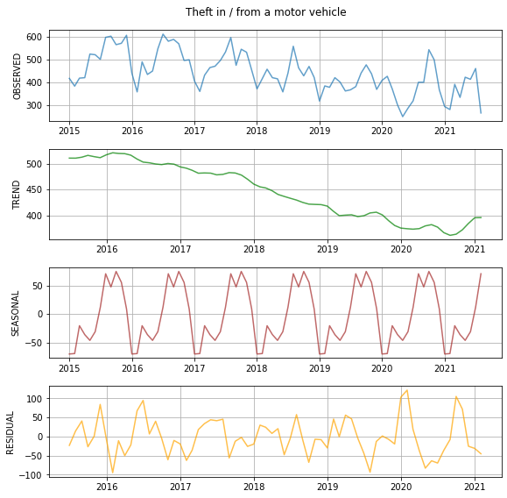

* Mischief – consistent, declining trend

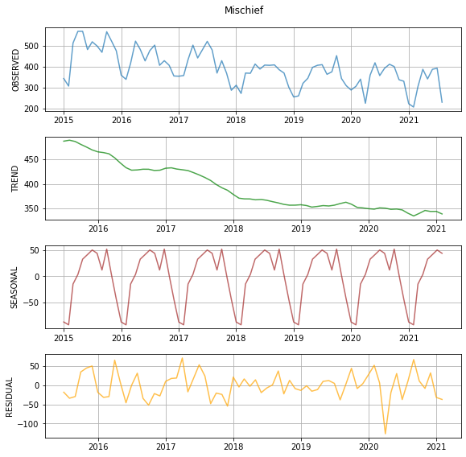

* Motor vehicle theft – initially an uptrend peaking in late 2017 and subsequently declining, has been on an uptrend since bottoming out in late 2018 and surpassing the prior peak

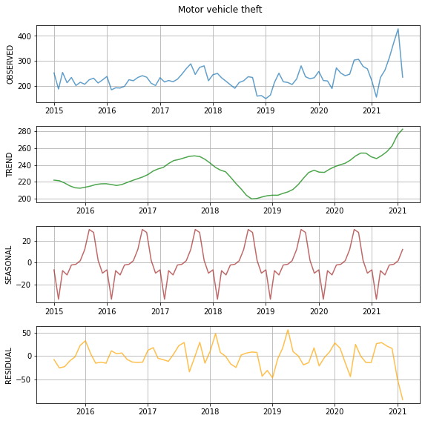

* Confirmed theft – overall consistent, declining downtown while holding relatively flat between 2018 to mid-2019

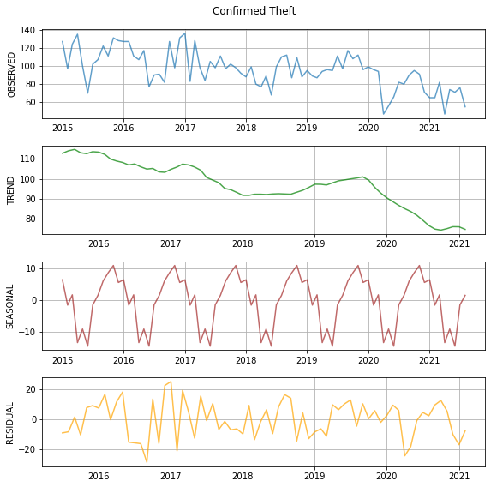

**What month(s) is criminal activity most likely to occur (including the types of crime)?**

Per our decomposition analysis on monthly data, the following crime types appears to be more prominent in the following months, as follows:

* Home invasion – peaks typically in the fall months and bottoms in mid-winter



* Theft in / from a motor vehicle – peaks typically in late fall to early winter and bottoms in mid-winter



* Mischief – peaks typically in the spring and summer months and bottoms briefly in mid-winter



* Motor vehicle theft – peaks typically in the fall and bottoms briefly in mid-winter



* Confirmed theft – peaks activity in the fall and winter months and bottoms briefly in the spring months



**What communities are more afflicted with criminal activity over others (including the types of crime)?**

Montreal by a large margin leads any other city in terms of crime occurrence. Per the below chart, Montreal leads across all crime categories as compared to the next leading city, Montreal-Nord. The third and fourth place cities are also listed below.

|  |  |  |  |  |
| --- | --- | --- | --- | --- |
| Crime Category | Montreal | Montreal-Nord | Saint Leonard | Saint Laurent |
| Confirmed Theft | 74% | 5% | 2.6% | 2.5% |
| Home Invasion | 71% | 5% | 2.7% | 2.8% |
| Mischief | 68% | 5% | 2.6% | 2.8% |
| Motor vehicle theft | 57% | 9% | 6.1% | 5.6% |
| Theft in / from a motor vehicle | 68% | 4% | 4.1% | 3.5% |

The below chart provides the proportion of Offences resulting in death crimes by year, which clearly indicates Montreal as the leading contributor in this crime category as well.

|  |  |
| --- | --- |
| Proportion of Offences resulting in death - Montreal | |
| 2015 | 70.0% |
| 2016 | 57.9% |
| 2017 | 52.9% |
| 2018 | 78.9% |
| 2019 | 63.2% |
| 2020 | 75.0% |

When looking at individual neighborhoods in Montreal, the top trouble areas are as follows:

|  |  |
| --- | --- |
| Crime Type | Top 5 Neighborhoods |
| Confirmed Theft | Mercier Ahuntsic Riviere-des-Prairies Rosemount Villeray |
| Home Invasion | Plateau-Mont-Royal Centre-Sud Rosemount Petite-Patrie Cote-des-Neiges |
| Mischief | Plateau-Mont-Royal Centre-Sud Petite-Patrie Mercier Downtown Montreal |
| Motor vehicle theft | Mercier Ahuntsic Rivierie-des-Prairie Rosemount Villeray |
| Theft in / from a motor vehicle | Downtown Montreal Plateau-Mont-Royal Centre-Sud Mercier Ahuntsic |

Finally, based on the map visualizations the occurrence / density profile year-over-year appears to remain consistent for each crime category.

# Recommendations

Key recommendations are as follows:

1. Below is a visual map of the key neighborhoods of interest within the city of Montreal (highlighted in yellow) and other cities of interest where majority of resources are required (roughly 80%) – namely Montreal-Nord, Saint-Leonard and Saint-Laurent (highlighted in blue).

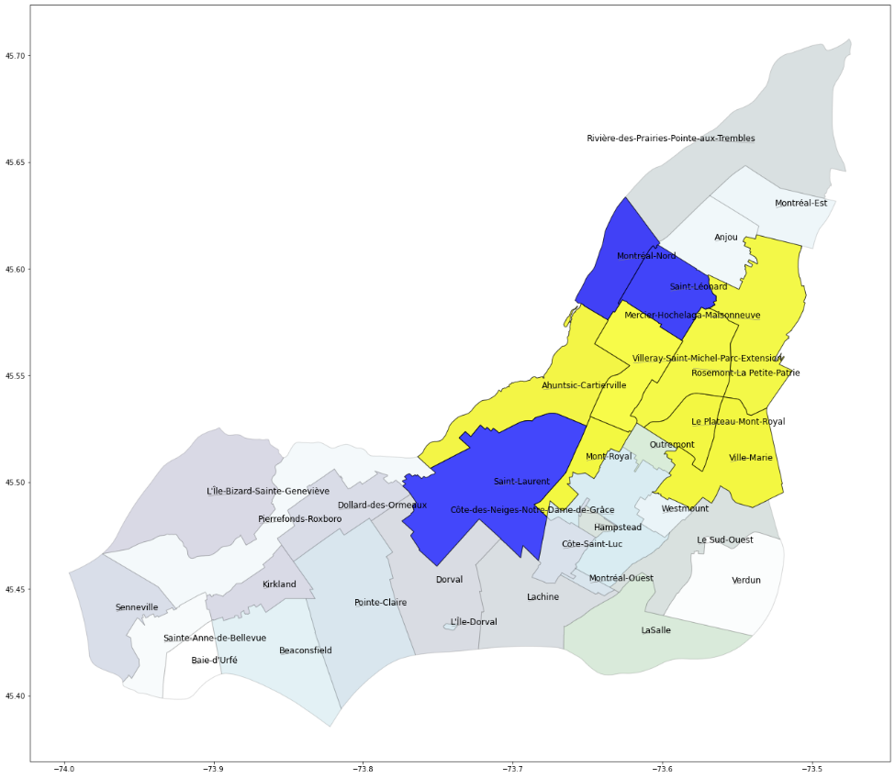

1. Crime categories across the region is declining except for Motor vehicle theft, which is increasing at a faster rate in Montreal then in all regions combined (i.e., 27% vs. 15%, respectively); therefore, this crime type requires special attention and requires more resources in order to reverse the uptrend. Another recommendation is to launch initiatives raising awareness and educating the population on preventative measures, which would similarly apply to Theft in / from a motor vehicle.
2. While Home invasions and Mischief are on a declining trend, they still comprise roughly half of all crime. Recommendation is to focus on specific neighborhoods where this is most prevalent and do further study on these crimes. For example, determine causes of downward trend to understand levers that may be used to reduce occurrences at a faster rate.

# Future Work

While this study analyzed categorical crime data only, for future work it is recommended to expand on this by incorporating additional datasets that includes demographic information by city and neighborhood such as: population size, age structures, economics and ethnic/racial composition. This additional information will support additional analysis including correlation analysis of crime as well as applying machine learning techniques in order to model prediction of crime occurrences.

# Appendix

## Dickey-Fuller Test

Motor vehicle theft :

ADF test statistic: -1.801868889172806

ADF p-values: 0.3795342375642533 -- Trend / Stationarity --

ADF number of lags used: 5

ADF number of observations: 74

ADF critical values: {'1%': -3.5219803175527606, '5%': -2.9014701097664504, '10%': -2.58807215485756}

ADF best information criterion: 671.327199154093

Home Invasion :

ADF test statistic: 0.751384261524733

ADF p-values: 0.9908094751189004 -- Trend / Stationarity --

ADF number of lags used: 9

ADF number of observations: 70

ADF critical values: {'1%': -3.5274258688046647, '5%': -2.903810816326531, '10%': -2.5893204081632653}

ADF best information criterion: 754.377477336493

Mischief :

ADF test statistic: -1.7530148915825658

ADF p-values: 0.4040251324876547 -- Trend / Stationarity --

ADF number of lags used: 11

ADF number of observations: 68

ADF critical values: {'1%': -3.530398990560757, '5%': -2.9050874099328317, '10%': -2.5900010121107266}

ADF best information criterion: 718.3966405348403

Theft in / from a motor vehicle :

ADF test statistic: -0.6870944012334637

ADF p-values: 0.8500641187666815 -- Trend / Stationarity --

ADF number of lags used: 11

ADF number of observations: 68

ADF critical values: {'1%': -3.530398990560757, '5%': -2.9050874099328317, '10%': -2.5900010121107266}

ADF best information criterion: 738.403100906188

Confirmed Theft :

ADF test statistic: -0.4977792522814607

ADF p-values: 0.8924491325624516 -- Trend / Stationarity --

ADF number of lags used: 7

ADF number of observations: 72

ADF critical values: {'1%': -3.524624466842421, '5%': -2.9026070739026064, '10%': -2.5886785262345677}

ADF best information criterion: 559.8034114282672

Offenses resulting in death :

ADF test statistic: -9.171437302700063

ADF p-values: 2.3824191462887928e-15 -- No Trend / Non-Stationarity --

ADF number of lags used: 0

ADF number of observations: 57

ADF critical values: {'1%': -3.5506699942762414, '5%': -2.913766394626147, '10%': -2.5946240473991997}

ADF best information criterion: 141.54081649258657

## Visual Map of Crime Occurrences – By Category and Year

### Motor Vehicle Theft

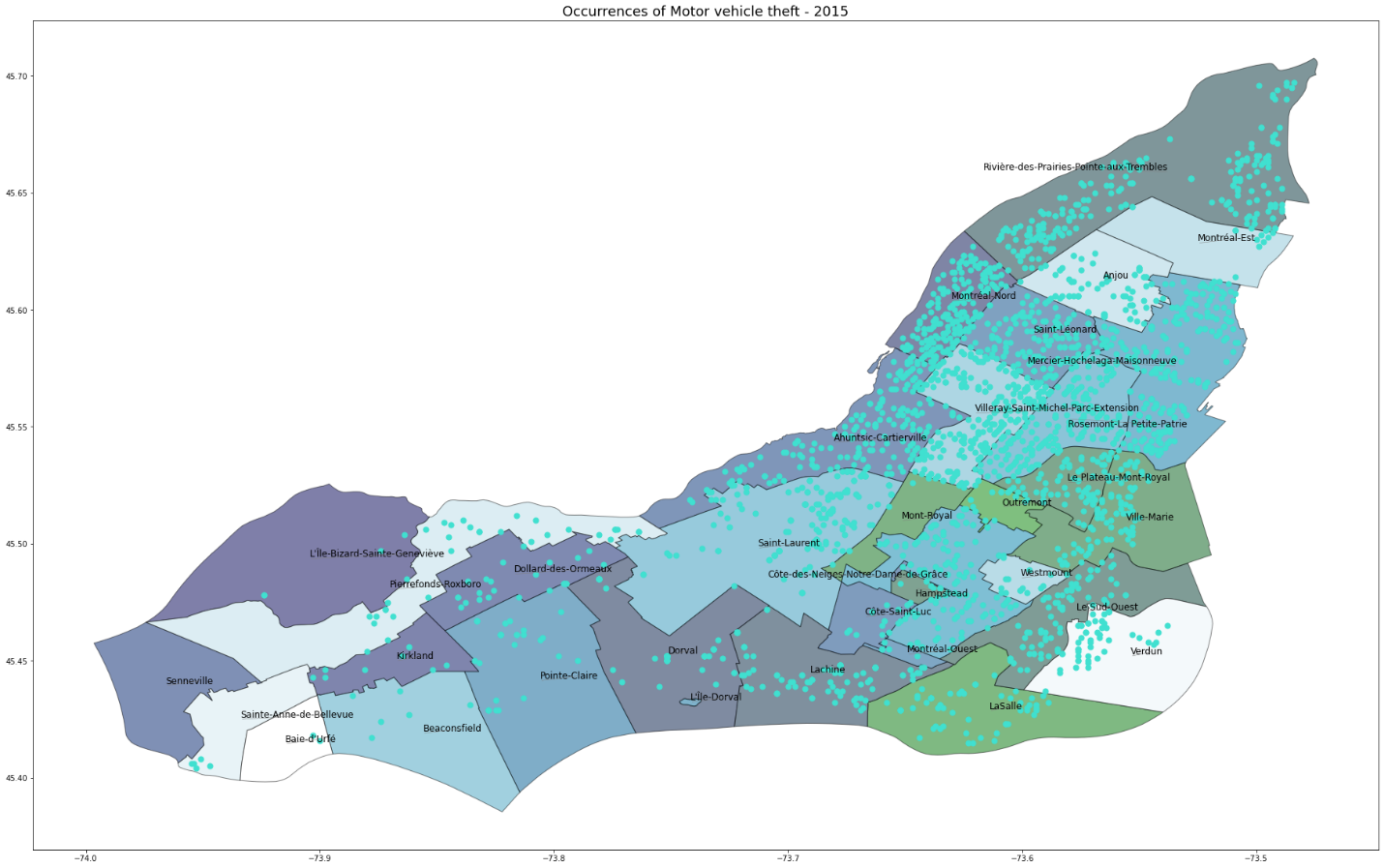

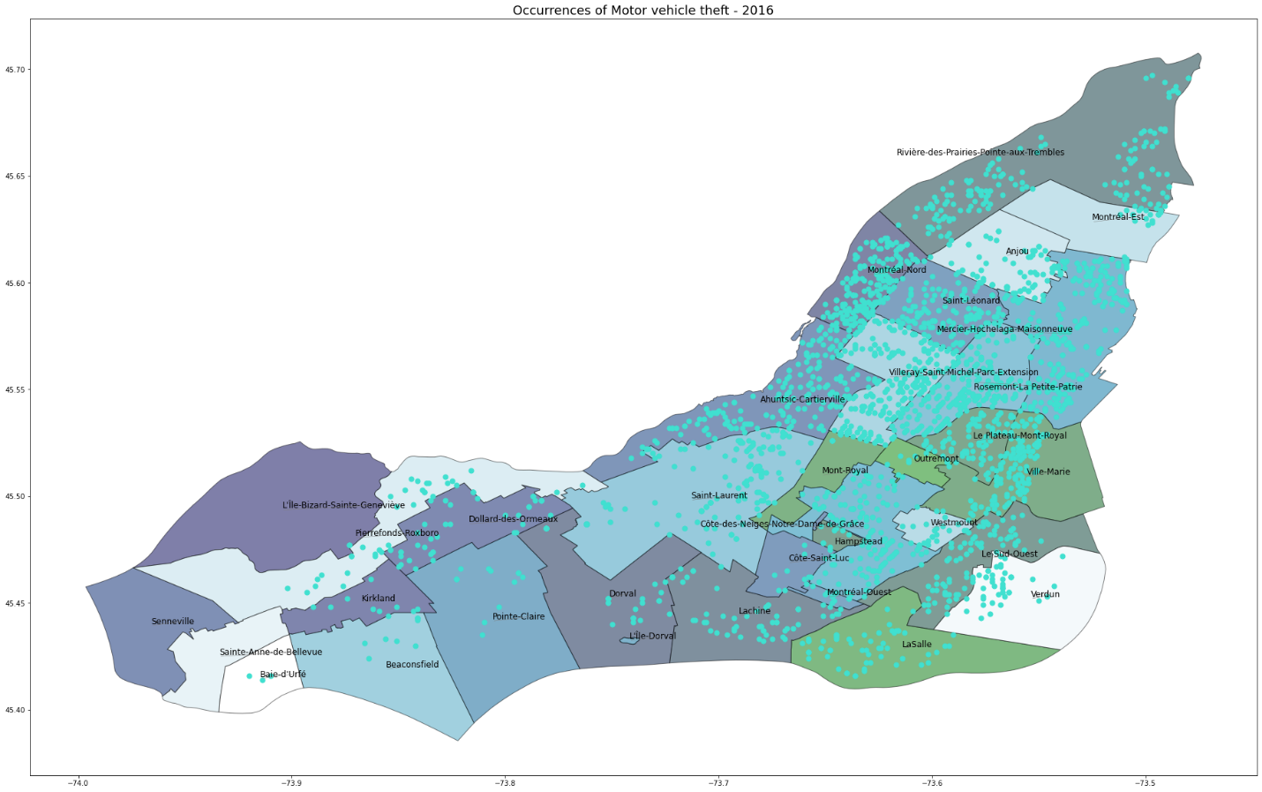

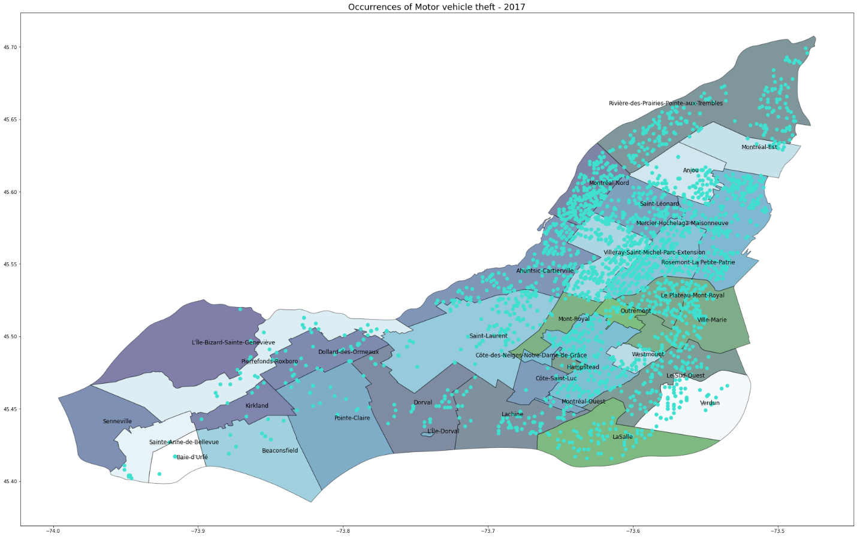

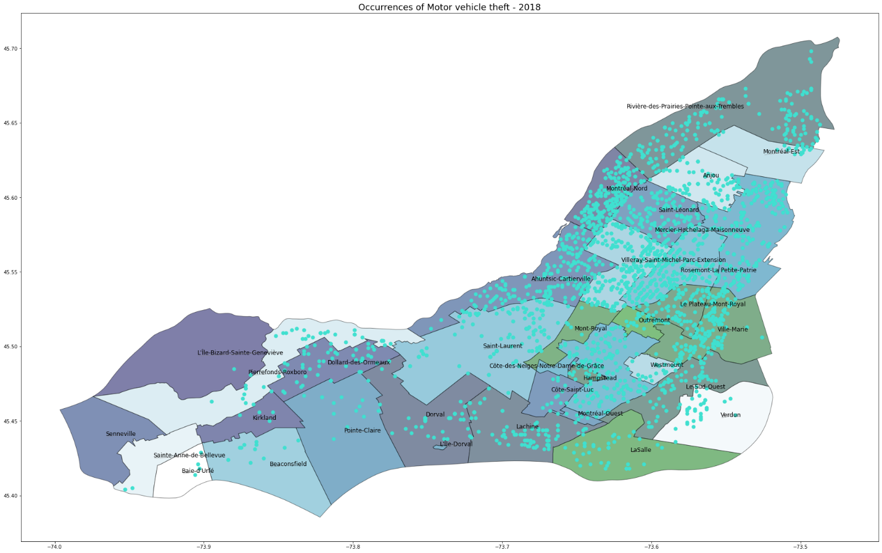

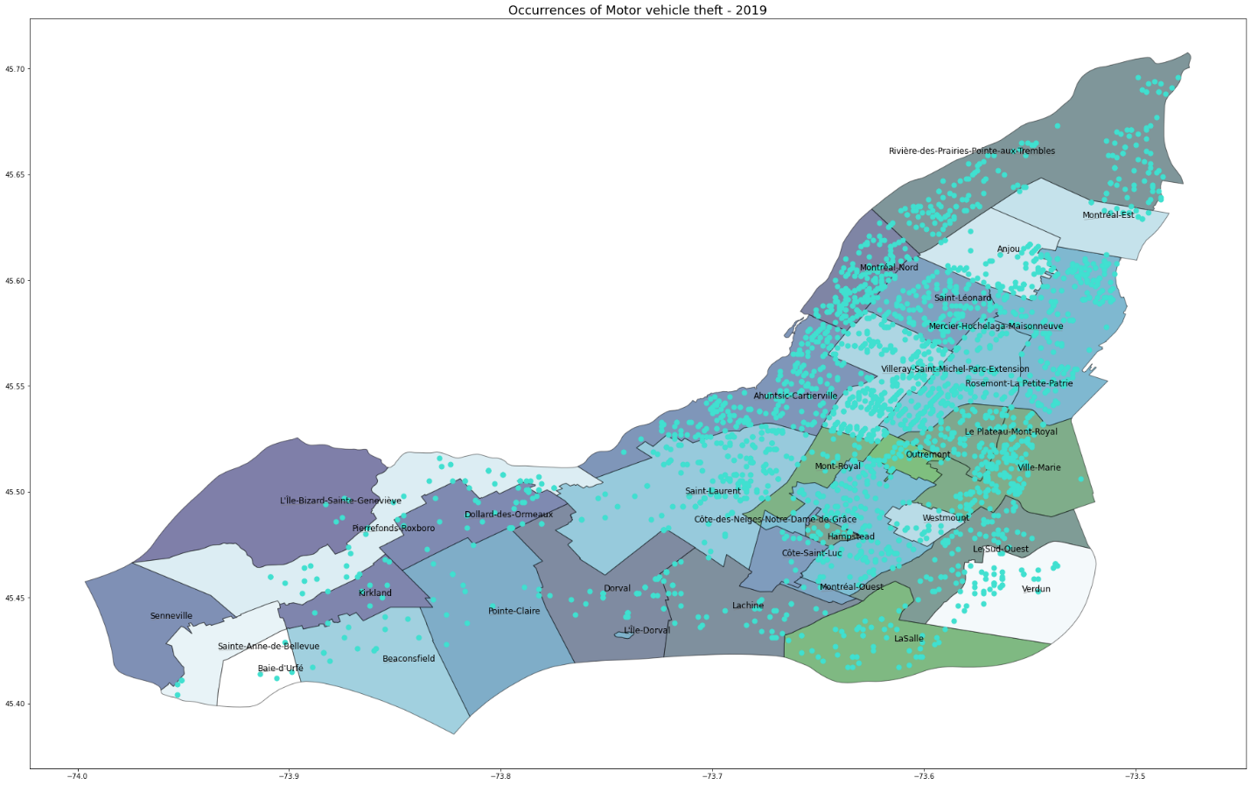

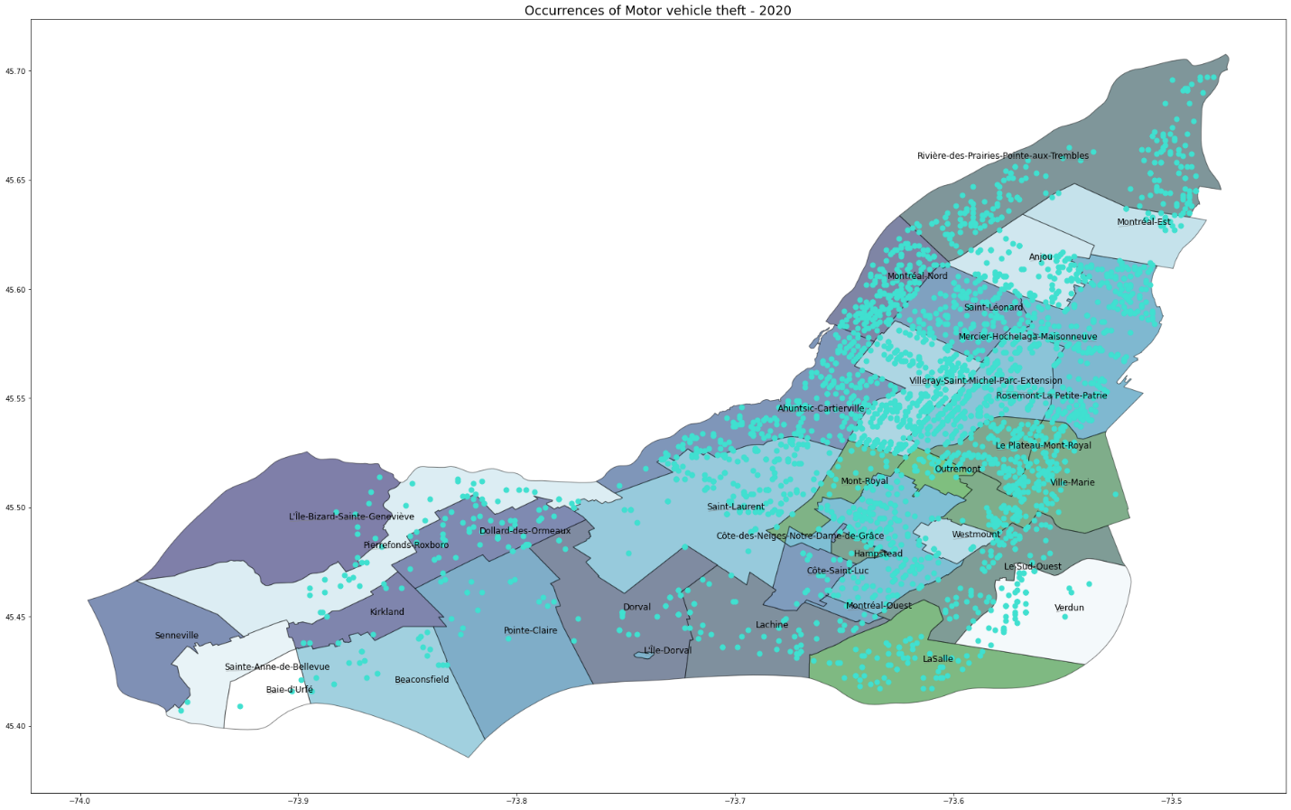

### Home Invasion

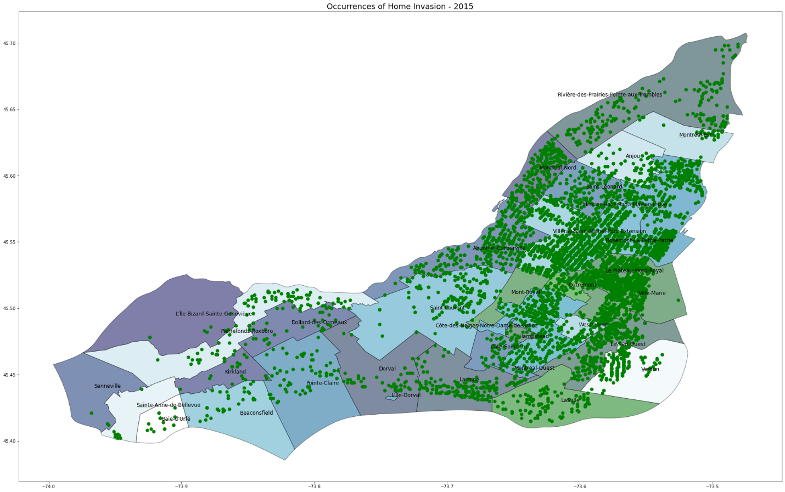

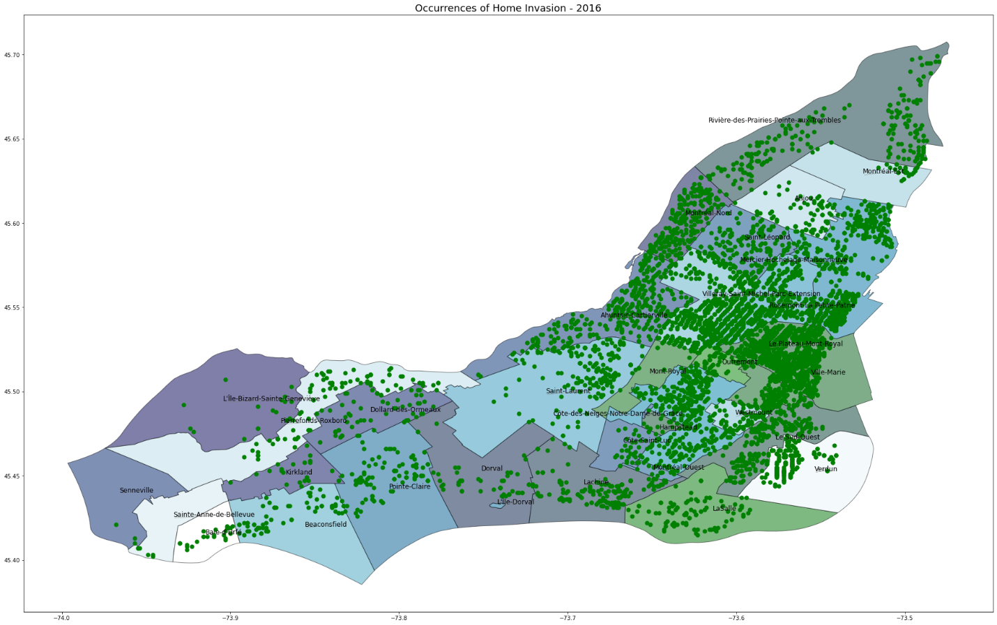

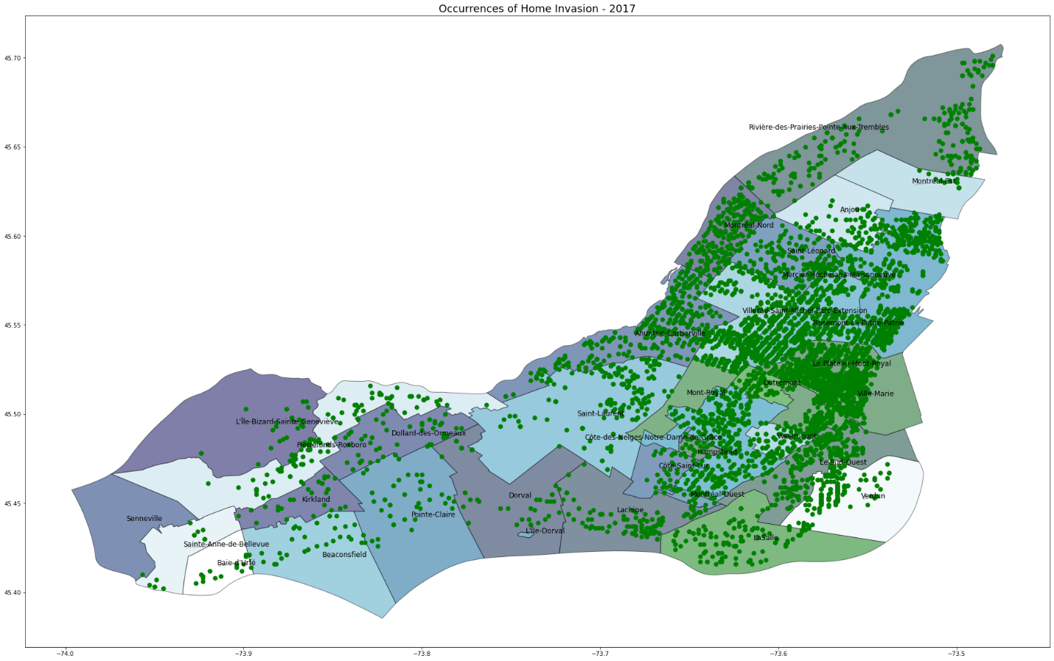

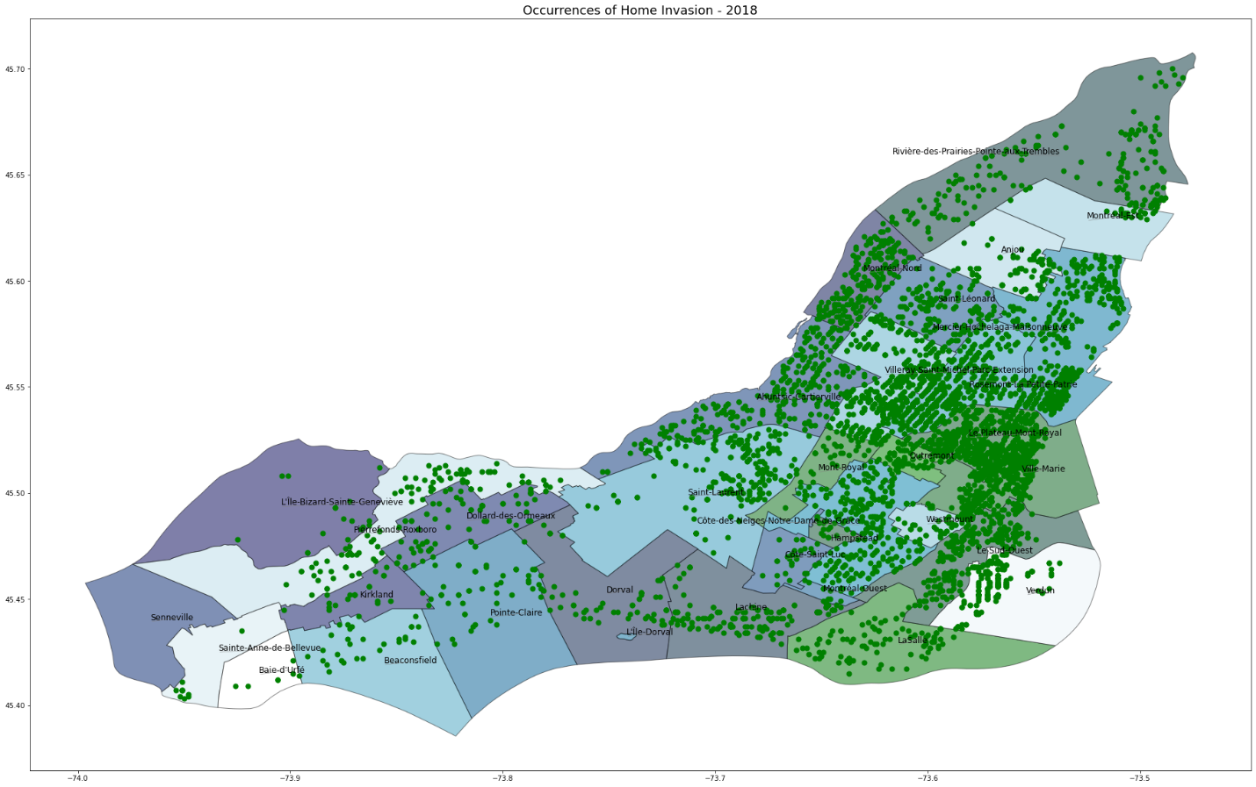

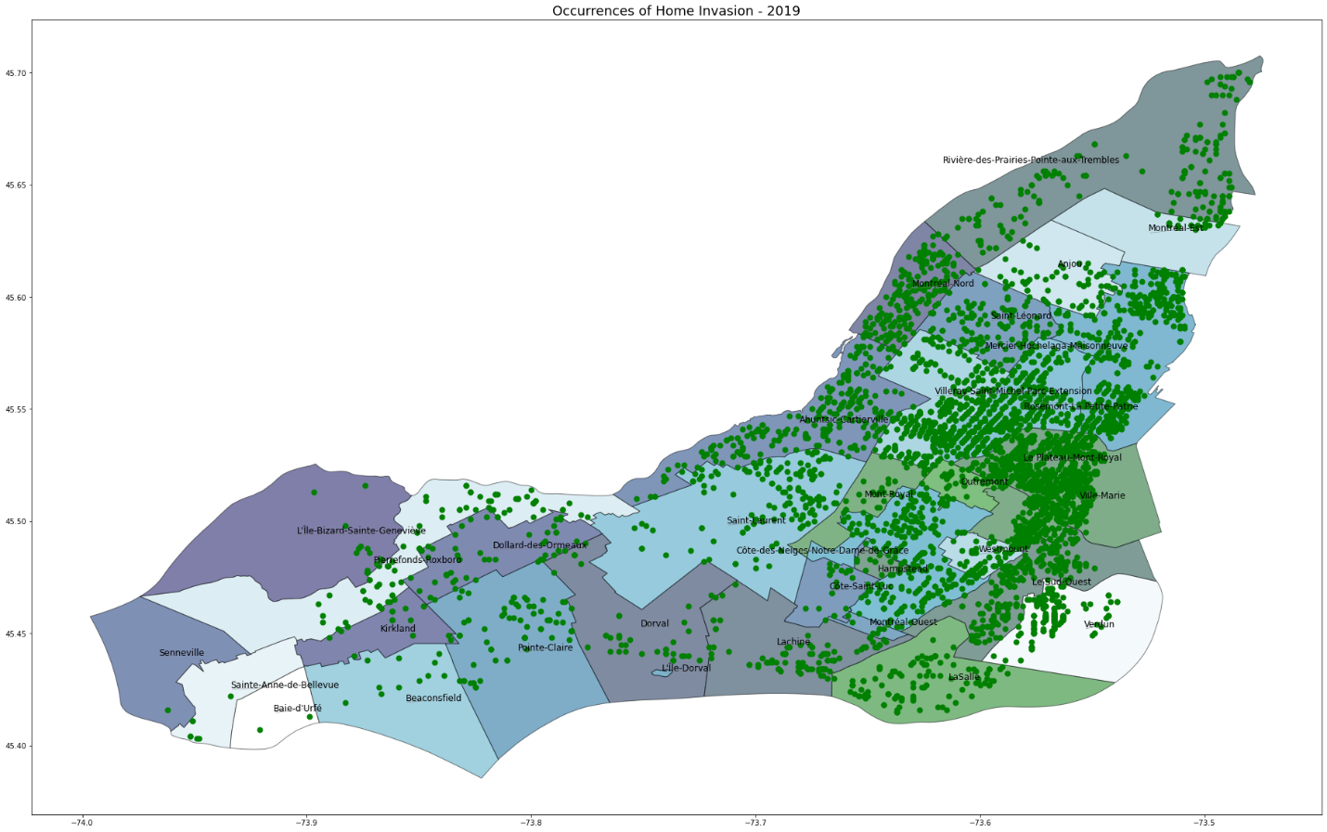

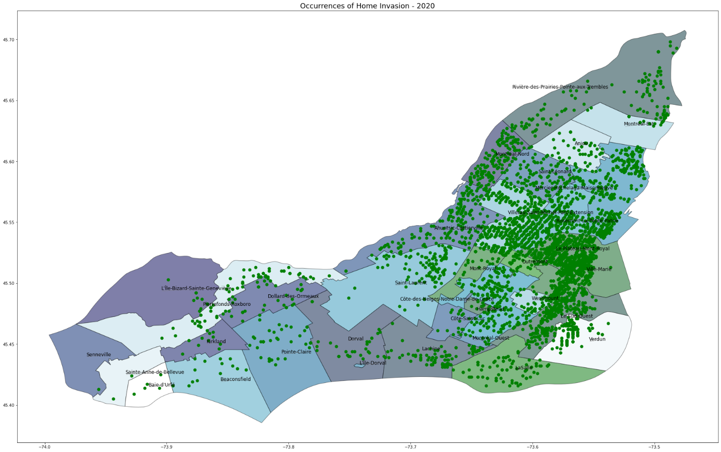

### Mischief

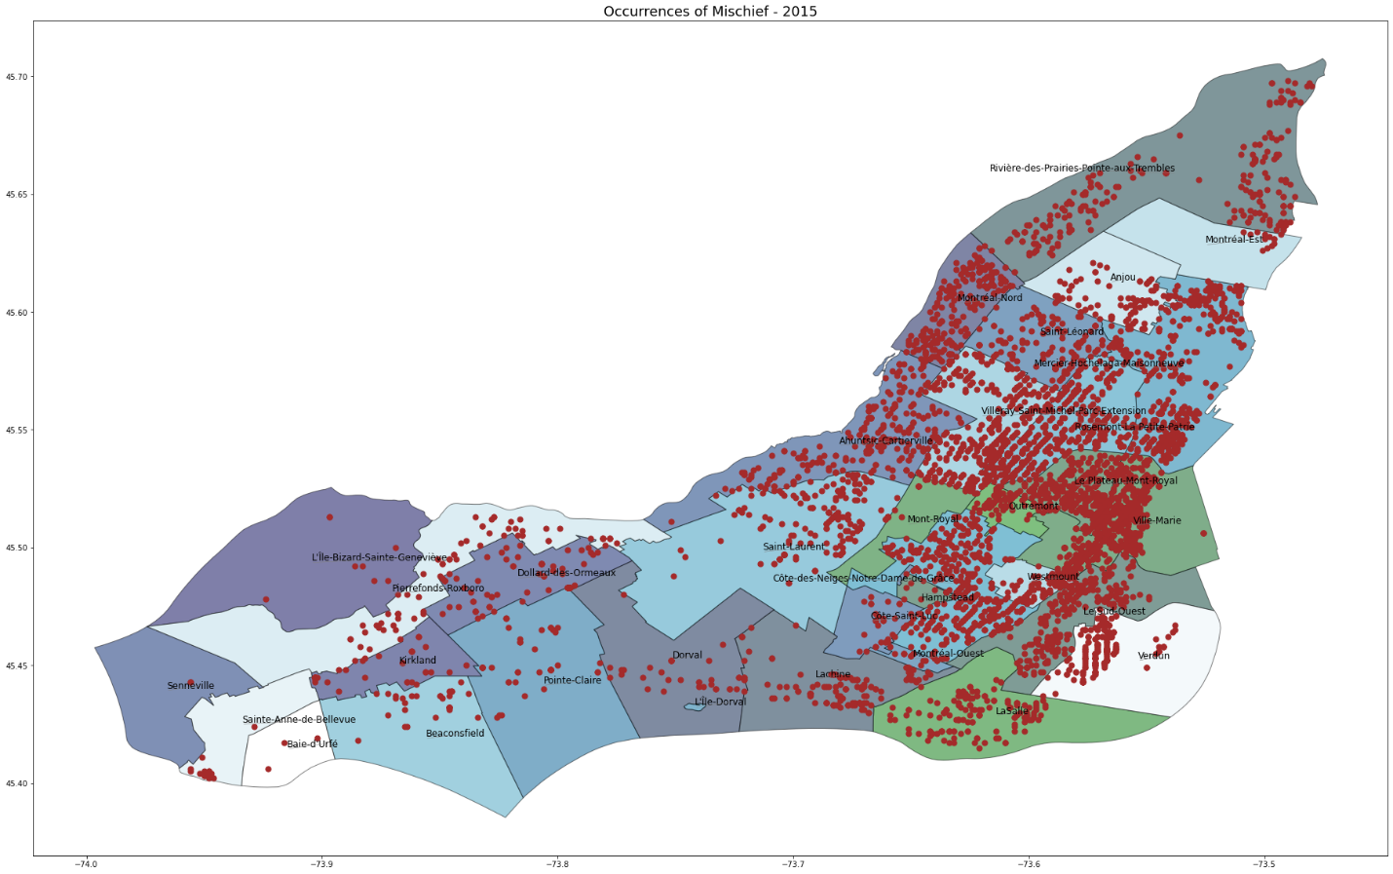

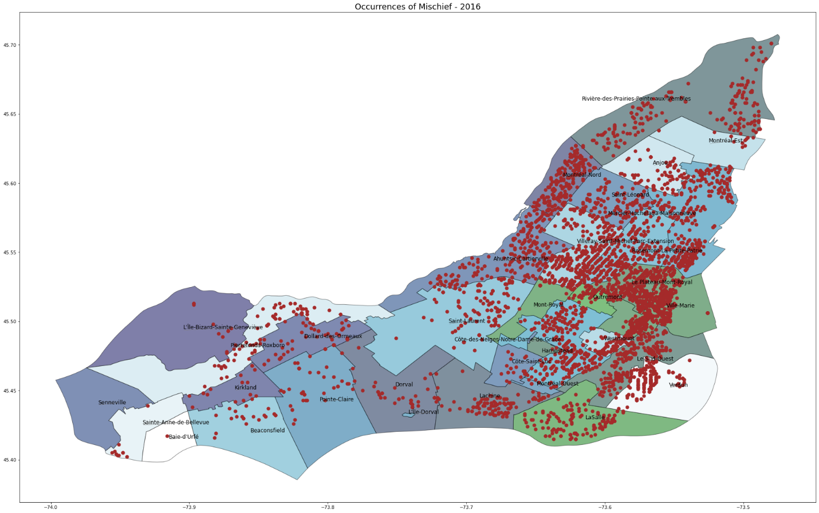

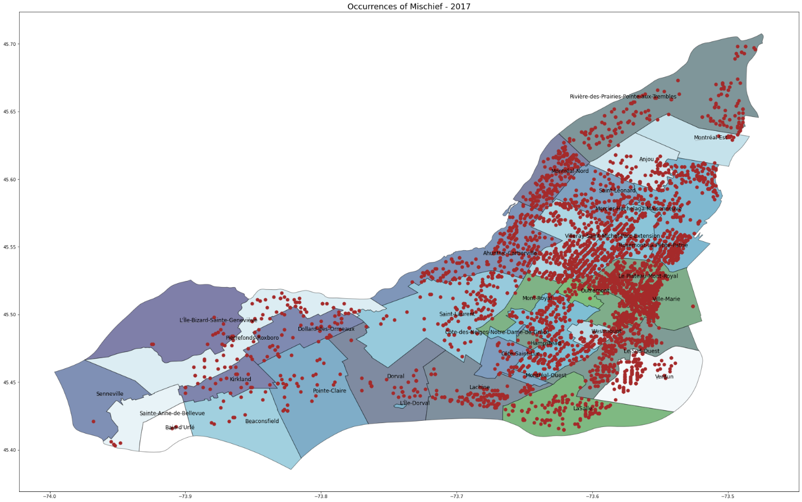

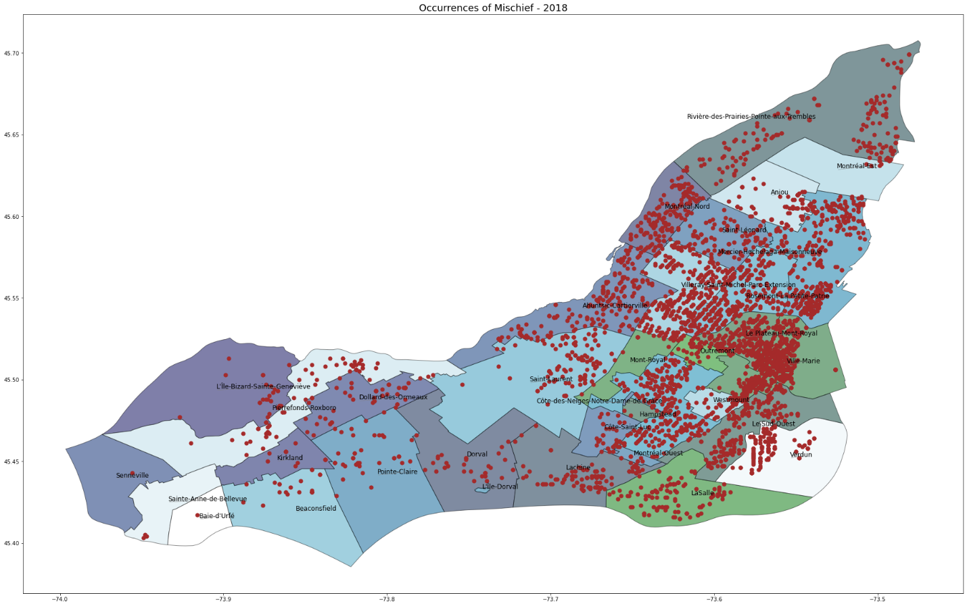

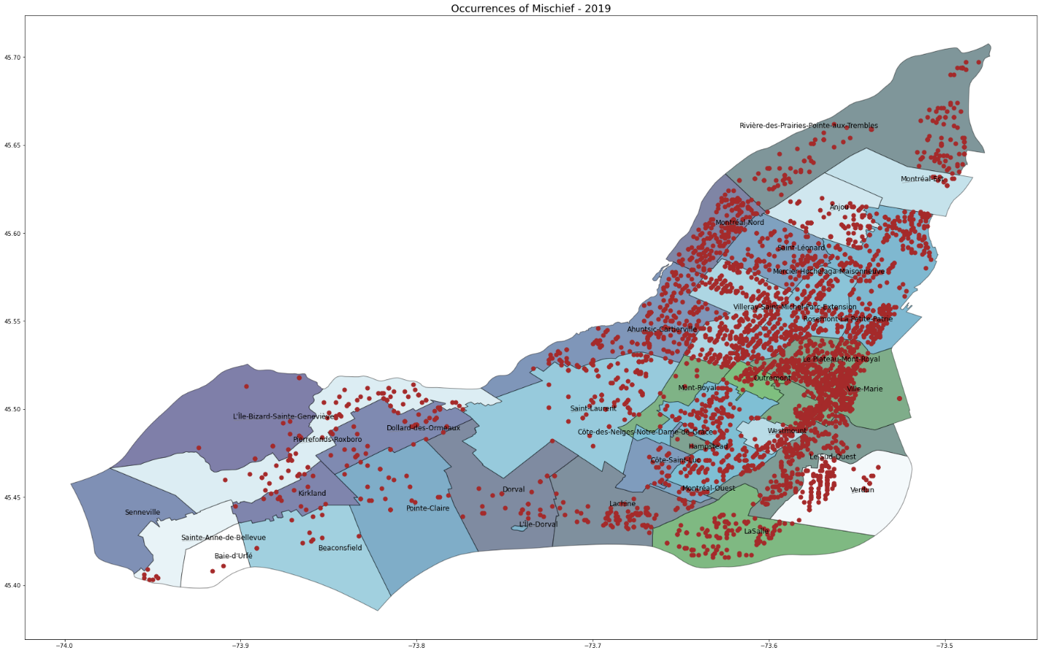

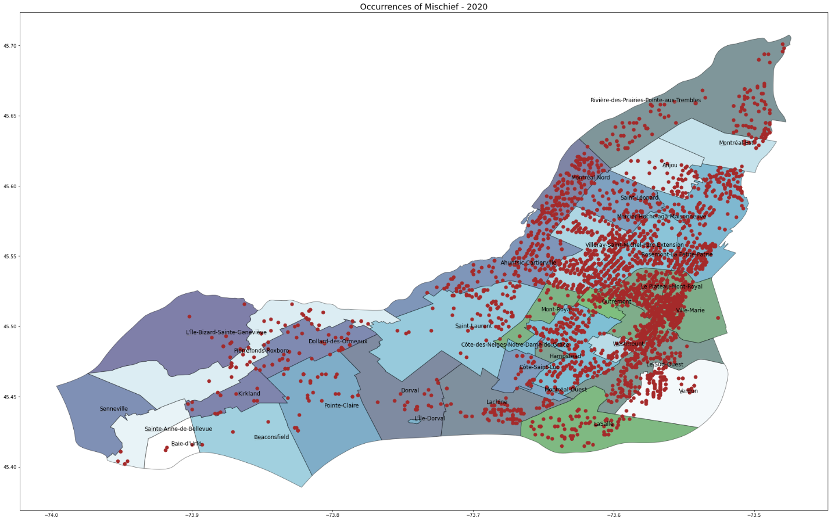

### Theft In / From a Motor Vehicle

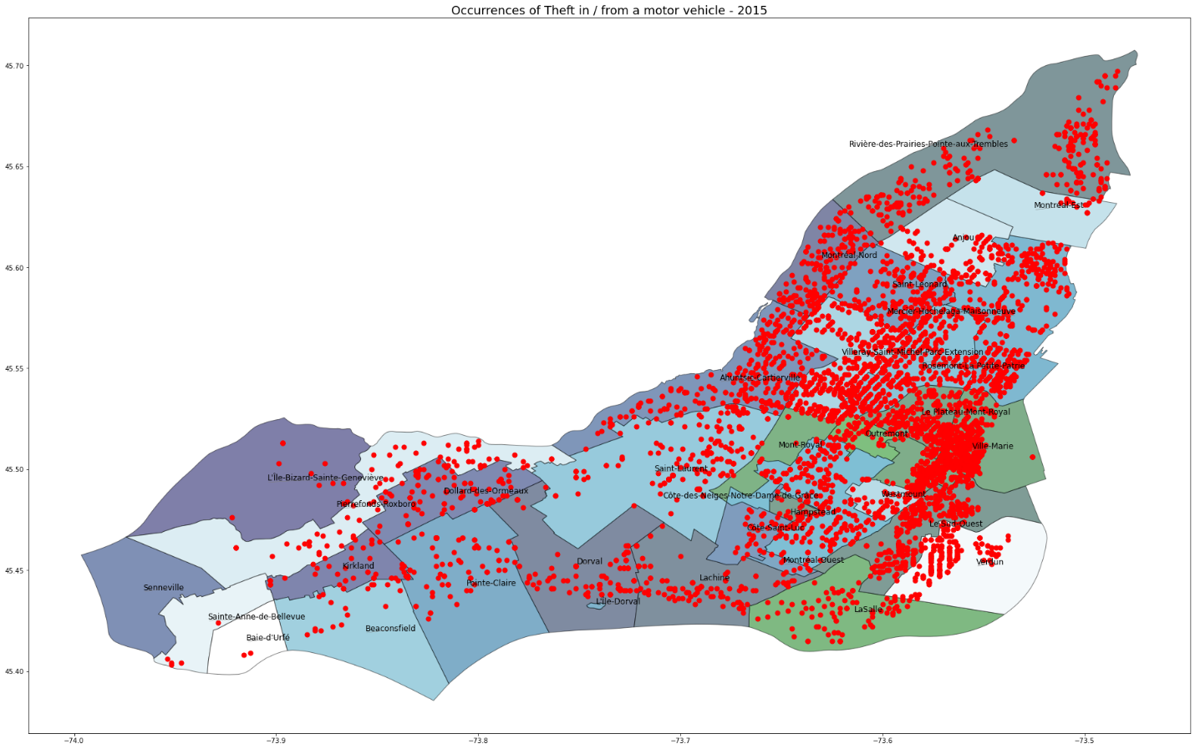

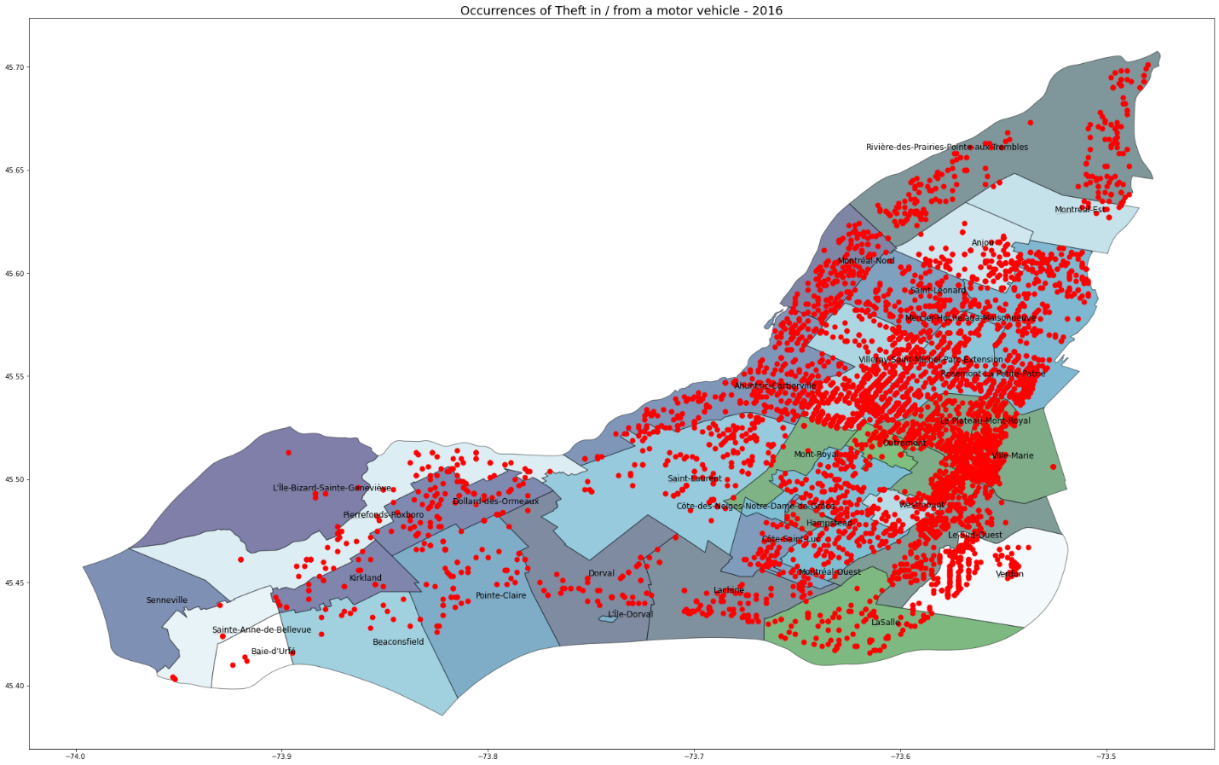

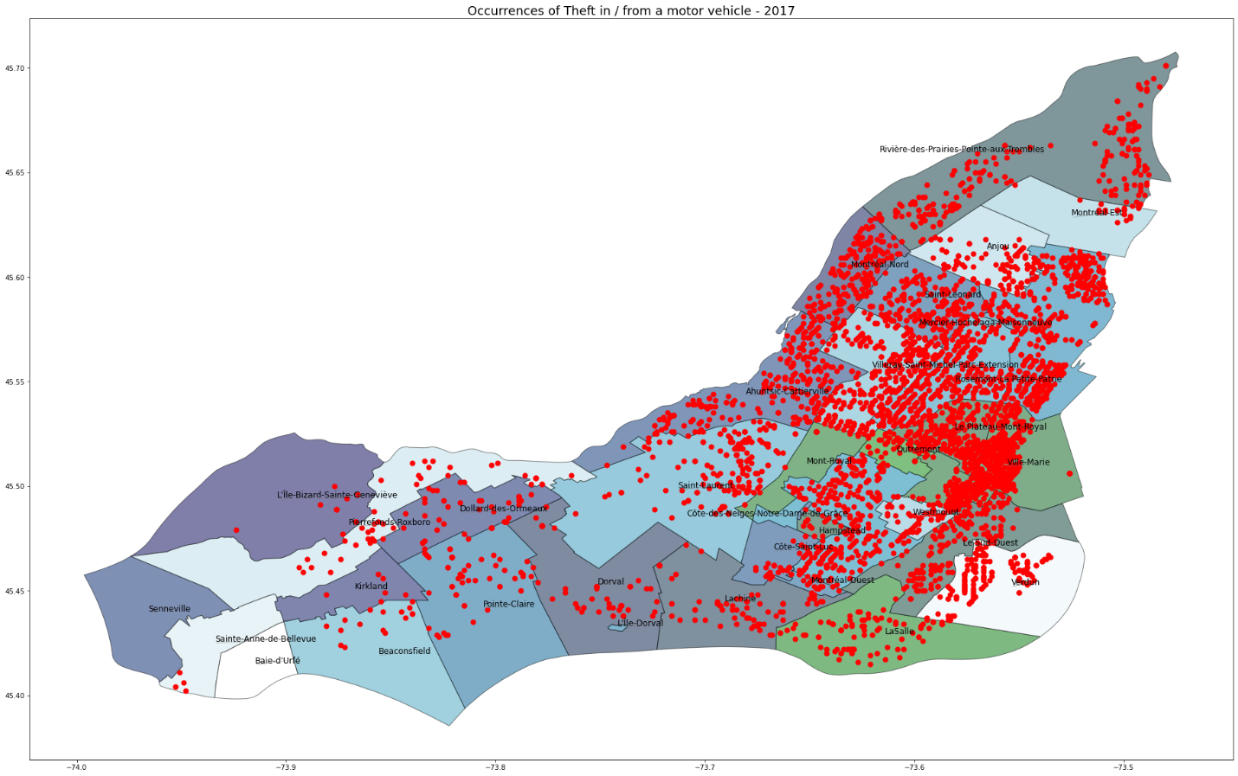

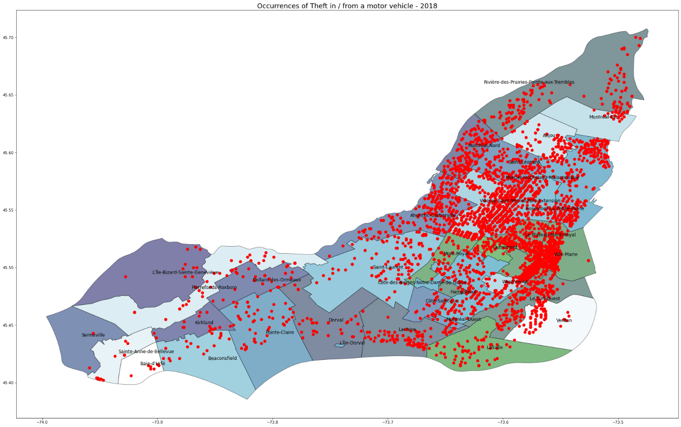

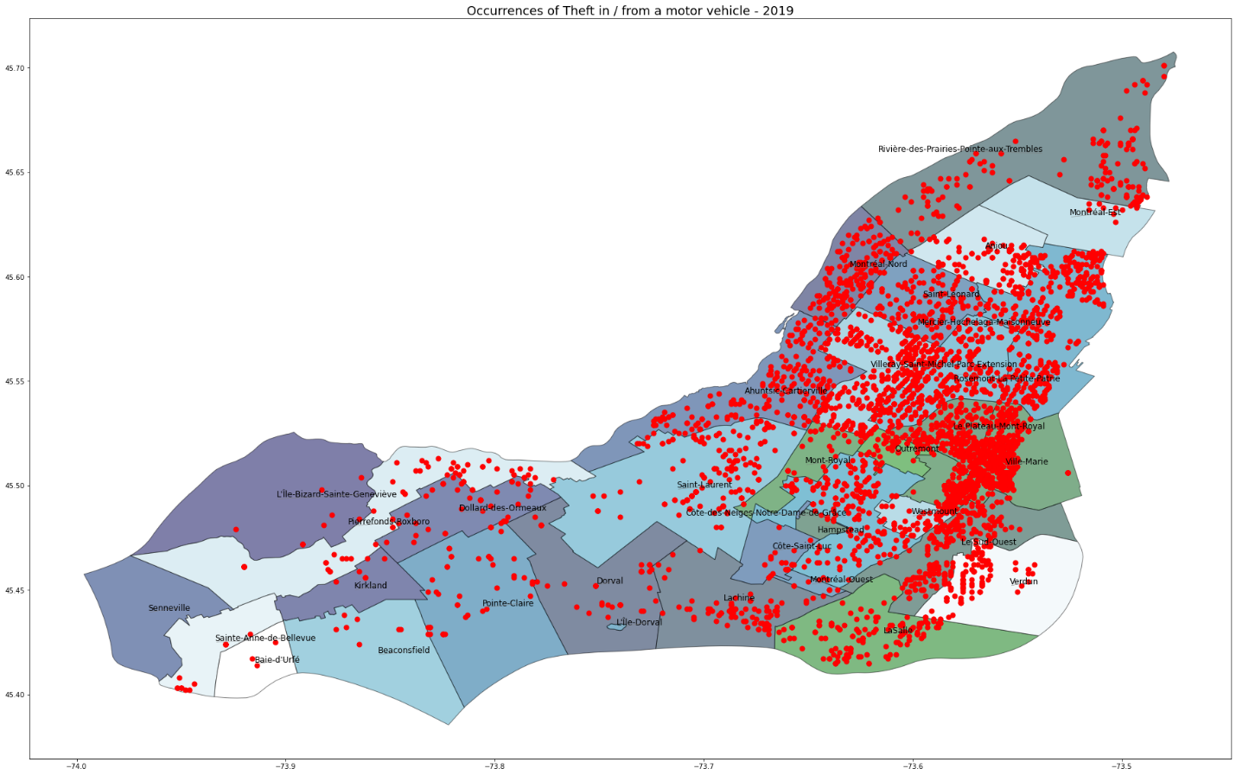

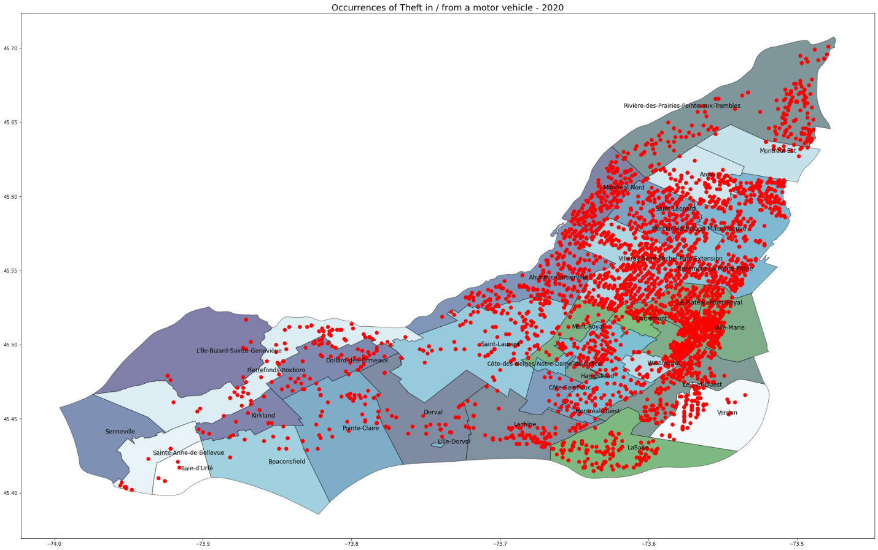

### Confirmed Theft

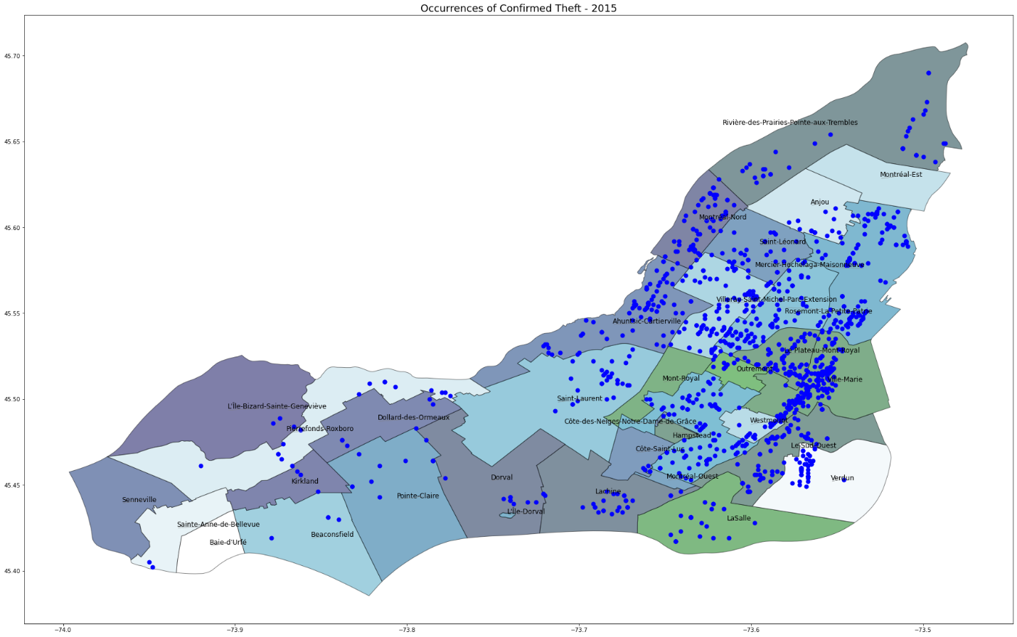

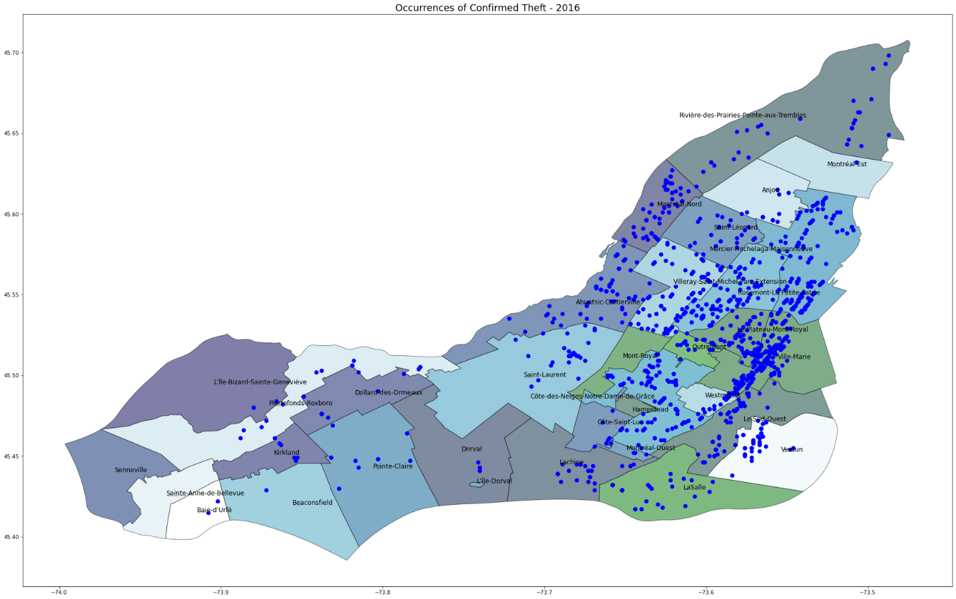

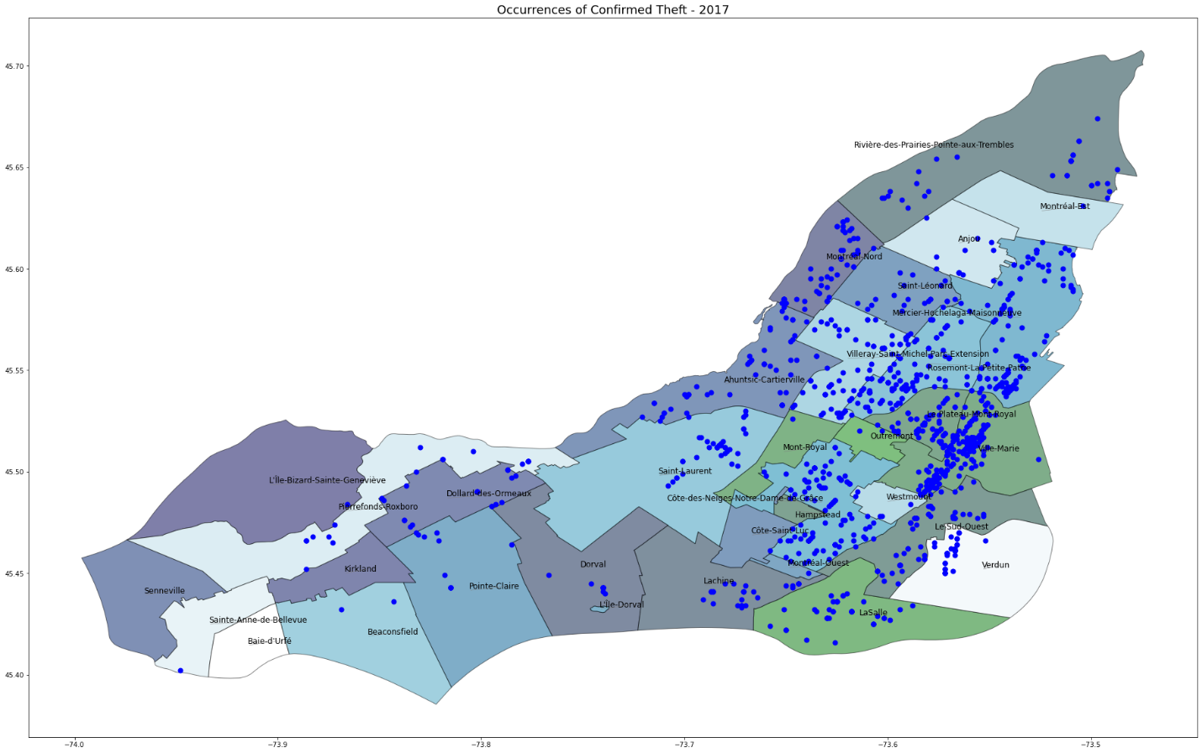

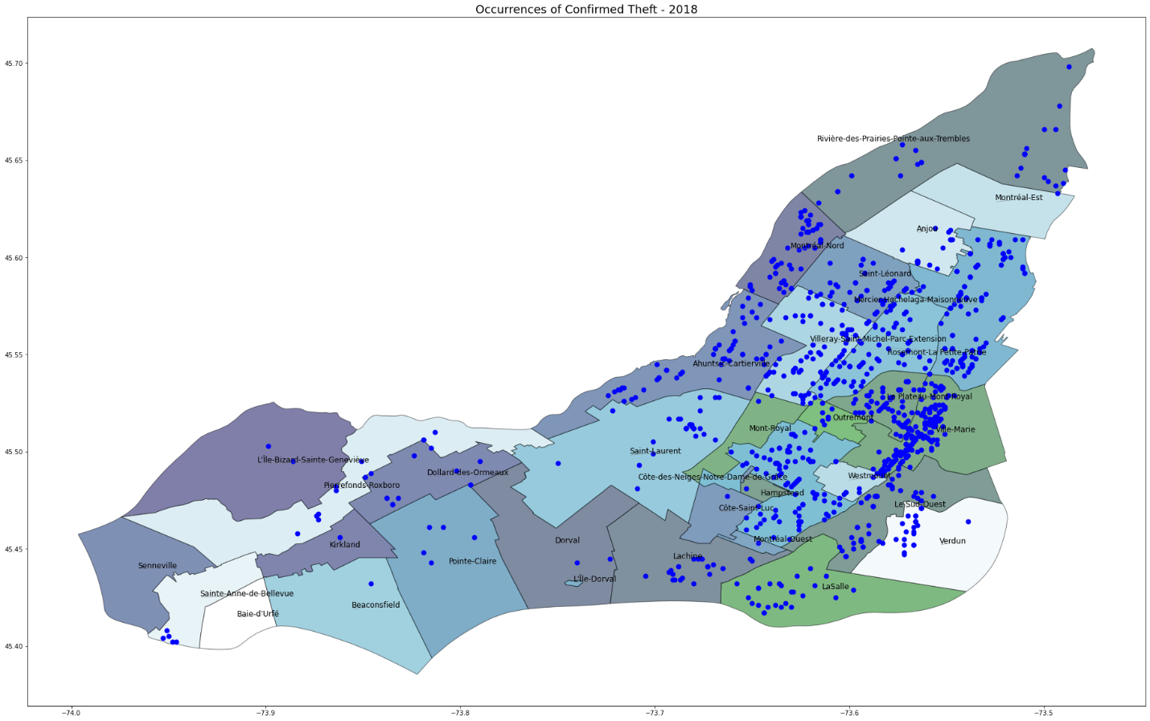

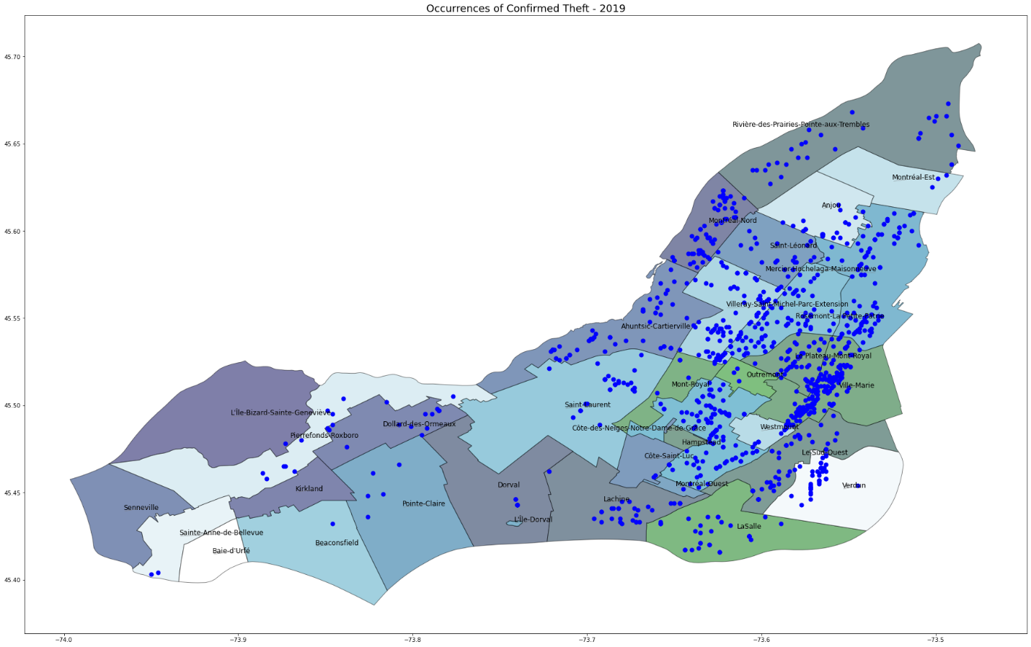

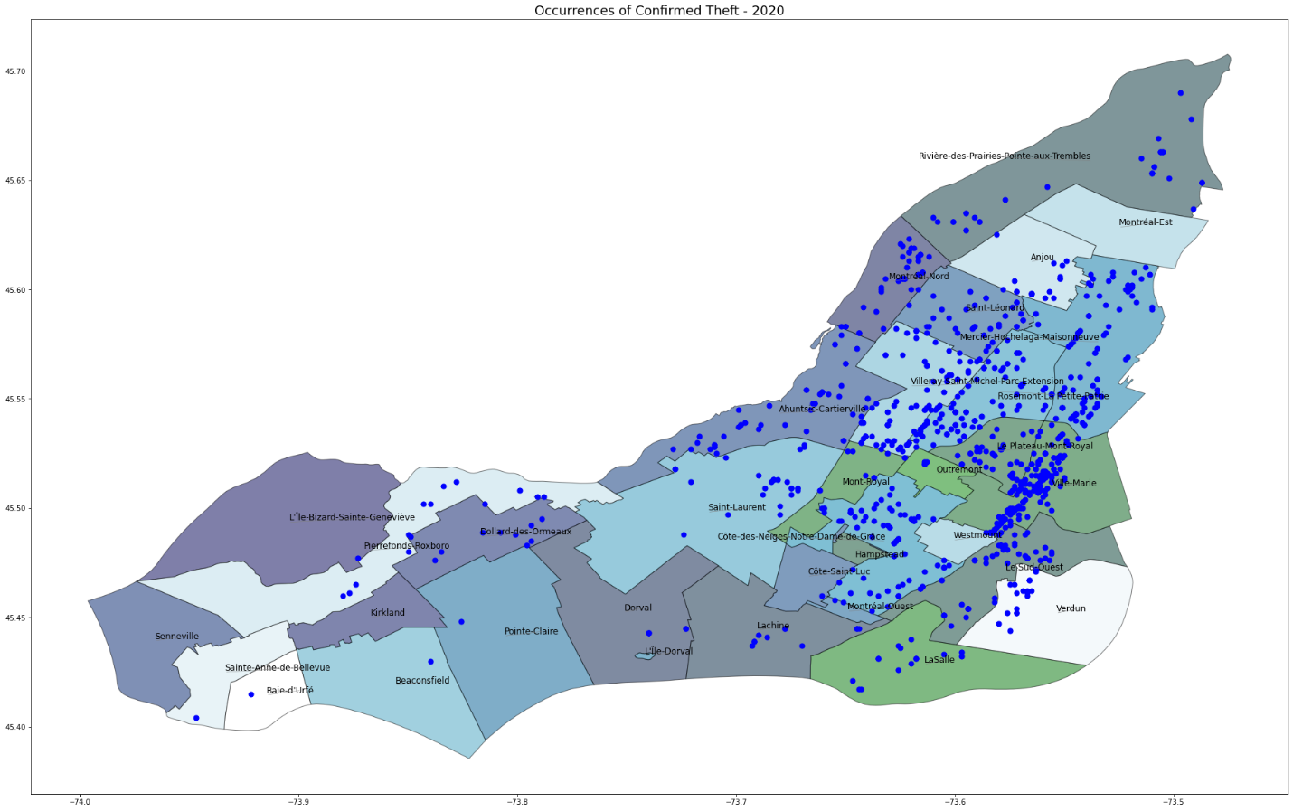

### Offenses Resulting in Death

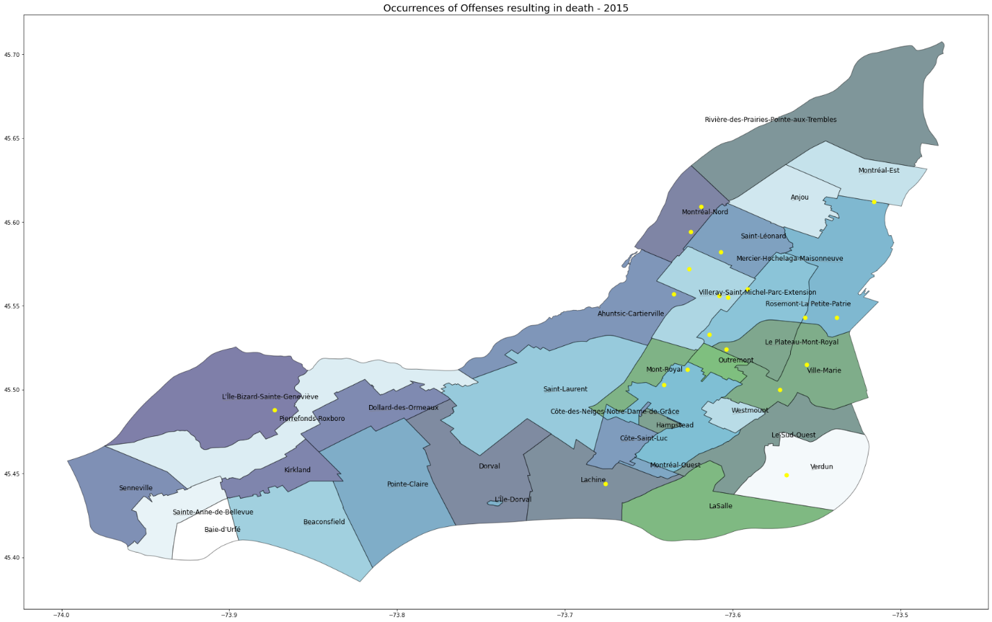

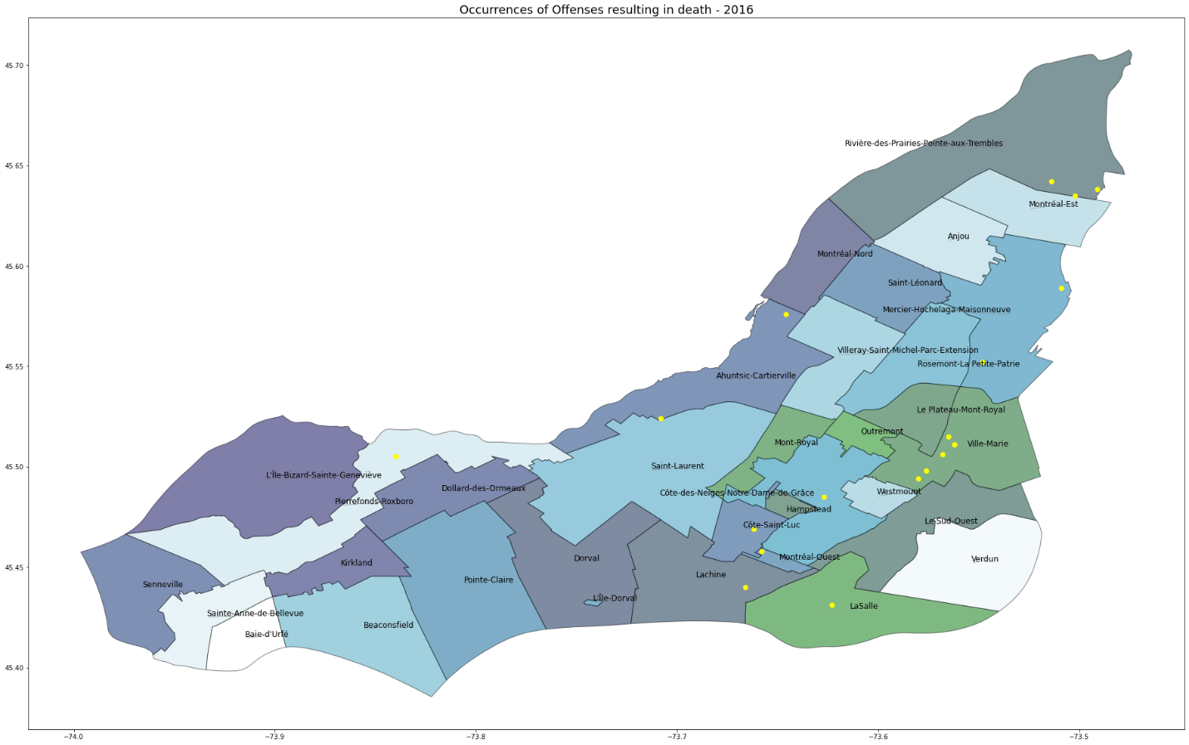

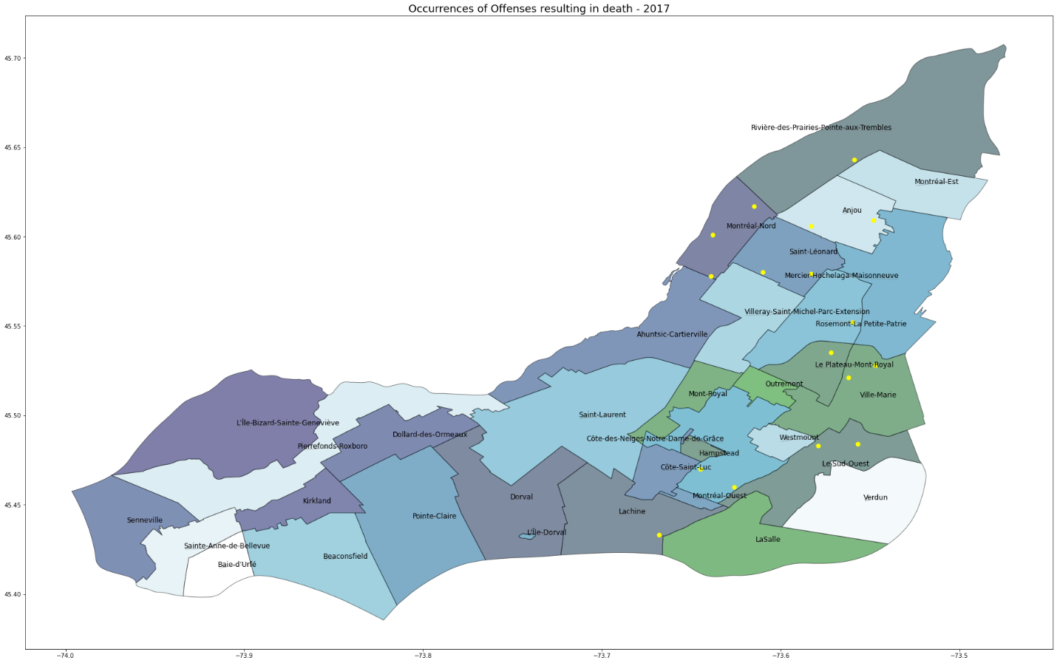

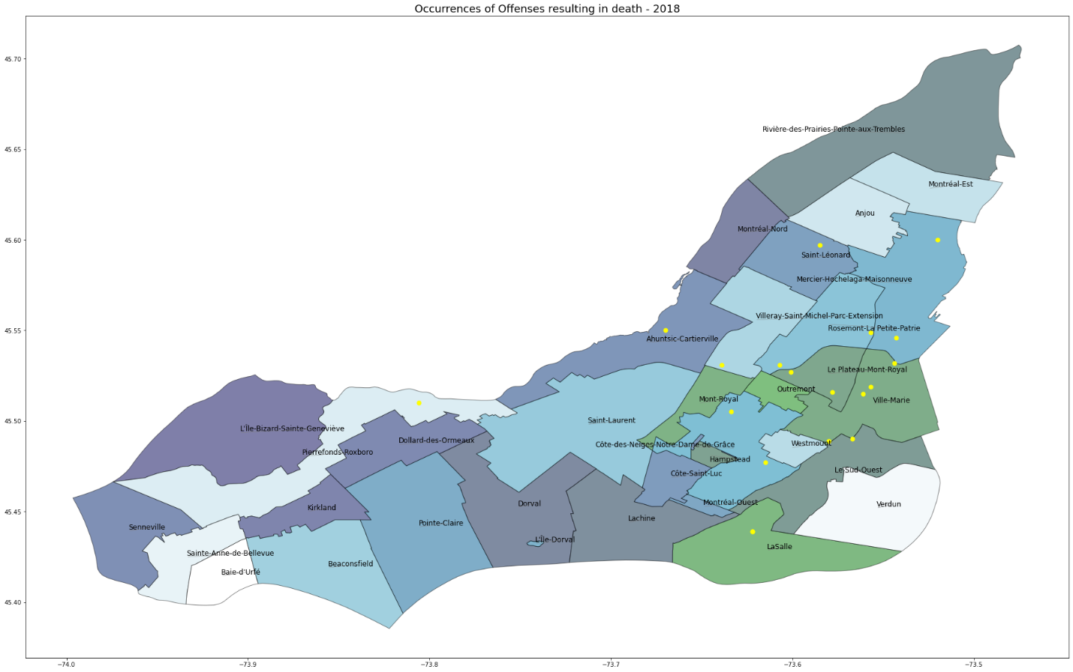

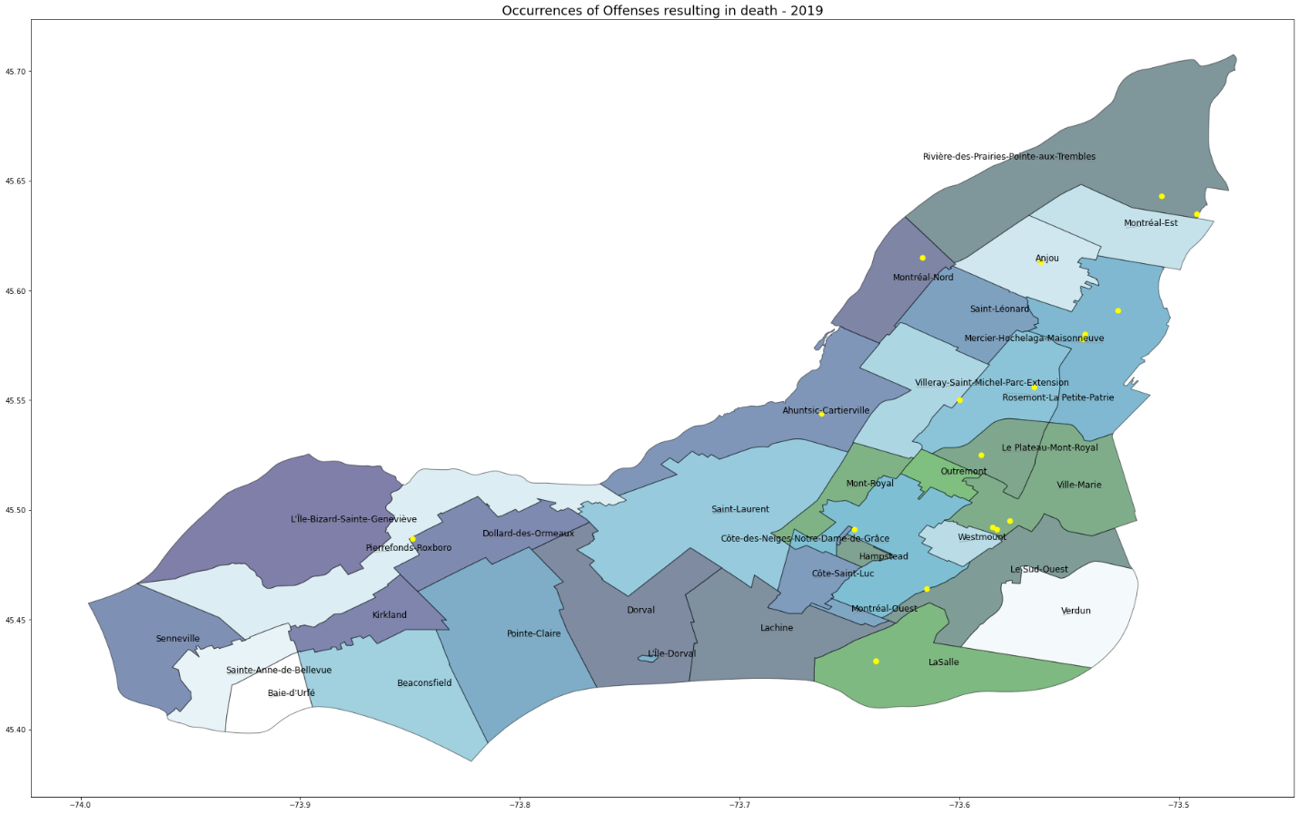

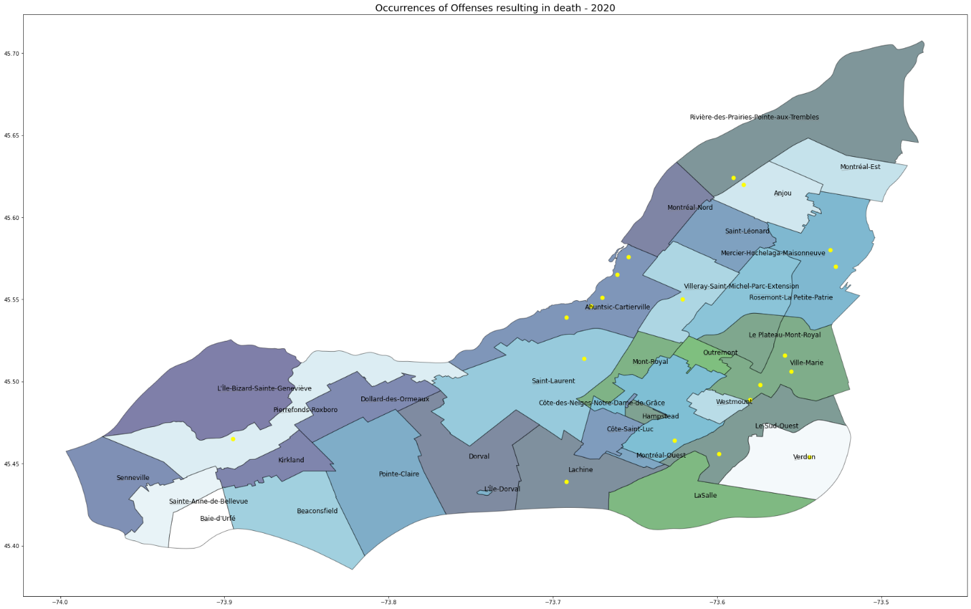

## ARIMA Test / Predict Plots

Below are the predicted outputs of the ARIMA model plotted against actual (test) values to compare the effectiveness of the model.

